Atom Structure

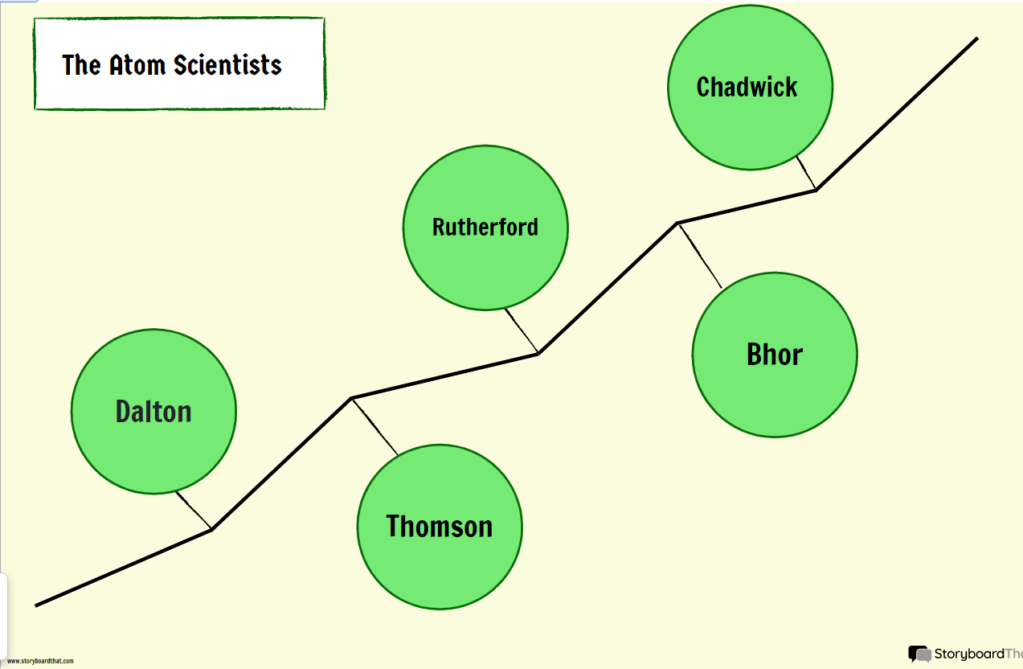

Main point of Daltons atomic theory

**Dalton's atomic theory** was the first complete attempt to describe all matter in terms of atoms and their properties. Dalton based his theory on the **law of conservation of mass** and the **law of constant composition**. The first part of his theory states that **all matter is made of atoms, which are indivisible**. The second part of the theory says **all atoms of a given element are identical in mass and properties**. The third part says **compounds are combinations of two or more different types of atoms**. The fourth part of the theory states that **a chemical reaction is a rearrangement of atoms**.

How has the atomic structure changed by time

Rutherford's experiment prompted a change in the atomic model. If the positive alpha particles mostly passed through the foil, but some bounced back. AND if they already knew that the electron was small and negative, then the atom must have a small positive nucleus with the electrons around them.

Niels Bohr improved Rutherford's model. Using mathematical ideas, he showed that electrons occupy shells or energy levels around the nucleus. The Dalton model has changed over time because of the discovery of subatomic particles

Rutherford's experiment prompted a change in the atomic model. If the positive alpha particles mostly passed through the foil, but some bounced back. AND if they already knew that the electron was small and negative, then the atom must have a small positive nucleus with the electrons around them