Names of the scientists who helped to develop the structure of the atom.

Development of The Structure of The Atom

* 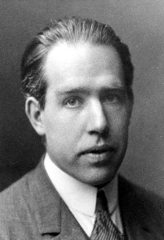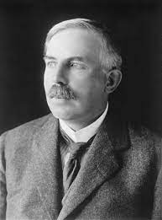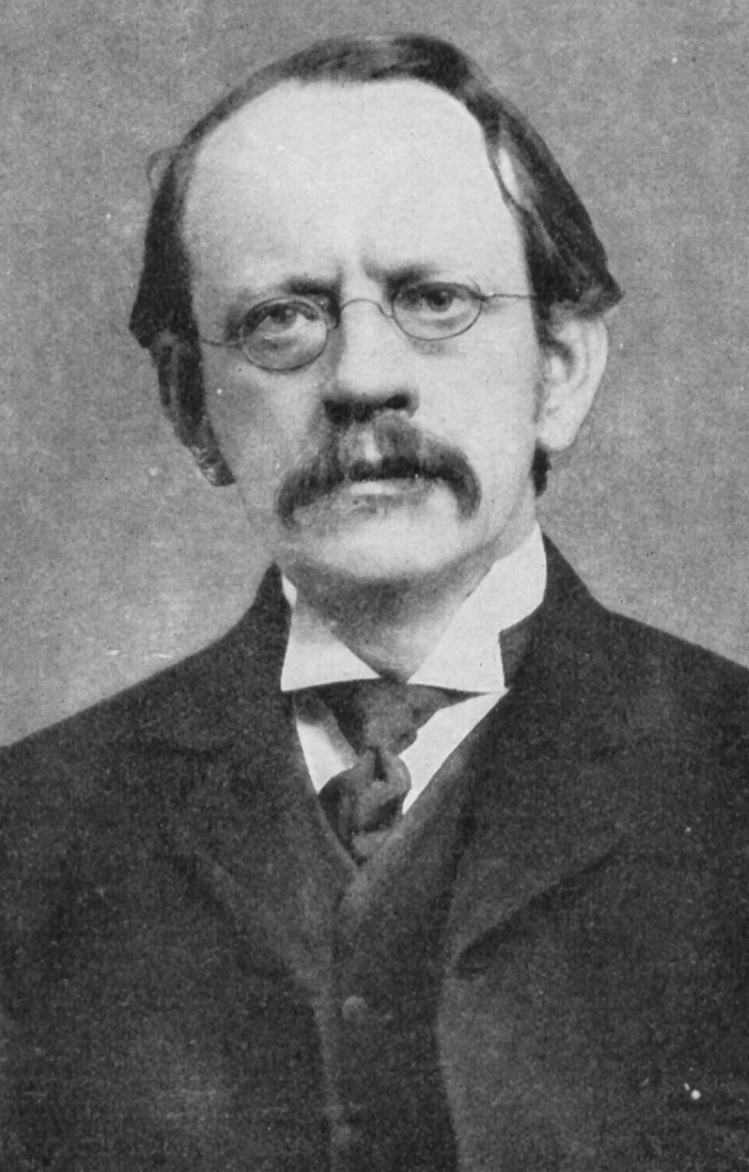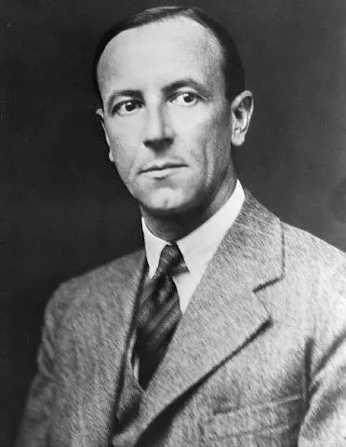**John Dalton**

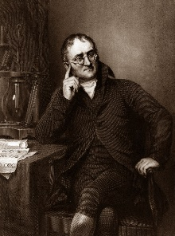

[This Photo](https://4vium.blogspot.com/2016/05/cientifico-cuaquero.html) by Unknown Author is licensed under [CC BY-NC](https://creativecommons.org/licenses/by-nc/3.0/)

* **J.J Thomson**
* **Ernest Rutherford**
* **Niels Bohr**
* **James Chadwick**

The importance of the atomic structure

**Meaning of Atomic structure**

To begin with, Atomic structure refers to the structure of an atom comprising a nucleus (centre) in which the protons (positively charged) and neutrons (neutral) are present. The negatively charged particles called electrons revolve around the center of the nucleus.

Why is it important to understand atomic structure?

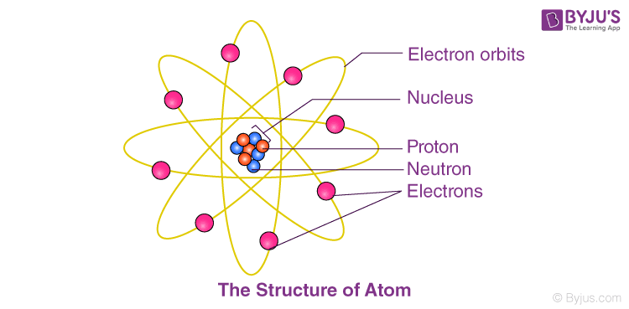 By learning about atomic structure, we can find out how atoms combine and form many compounds. By learning about atomic structure, we can find out how atoms collide. By learning about atomic structure, we can find out why atoms do not have mass. By learning about atomic structure, we can find out how atoms disappear.

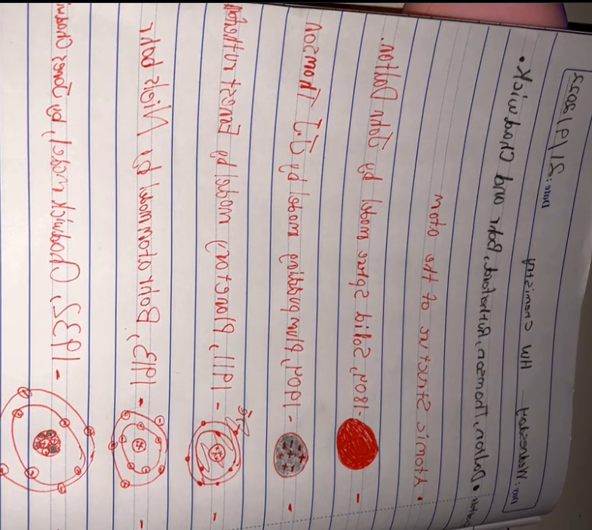

**By: Zaid Bakeer 7E**

*Note: my word was glitched so I wrote main course before starters.*

**The Main Points in Dalton’s atomic model**

**The following points are proposed by John Dalton:**

1. *All matter is made of very tiny particles called atoms.*
2. *Atoms of a given element are identical in mass and chemical properties.*
3. *Atoms of different elements have different masses and chemical properties*

**This is a model that shows the development in the structure of the atom.**

Blue = +tve

Green = -tve