= negative **Starters =**positive

• List the names of all scientists who helped to develop the structure of the atom.

**John Dalton, Thomas, RutherFord , Bohr and ChadWick.**

• Draw a model that shows the development in the structure of the atom

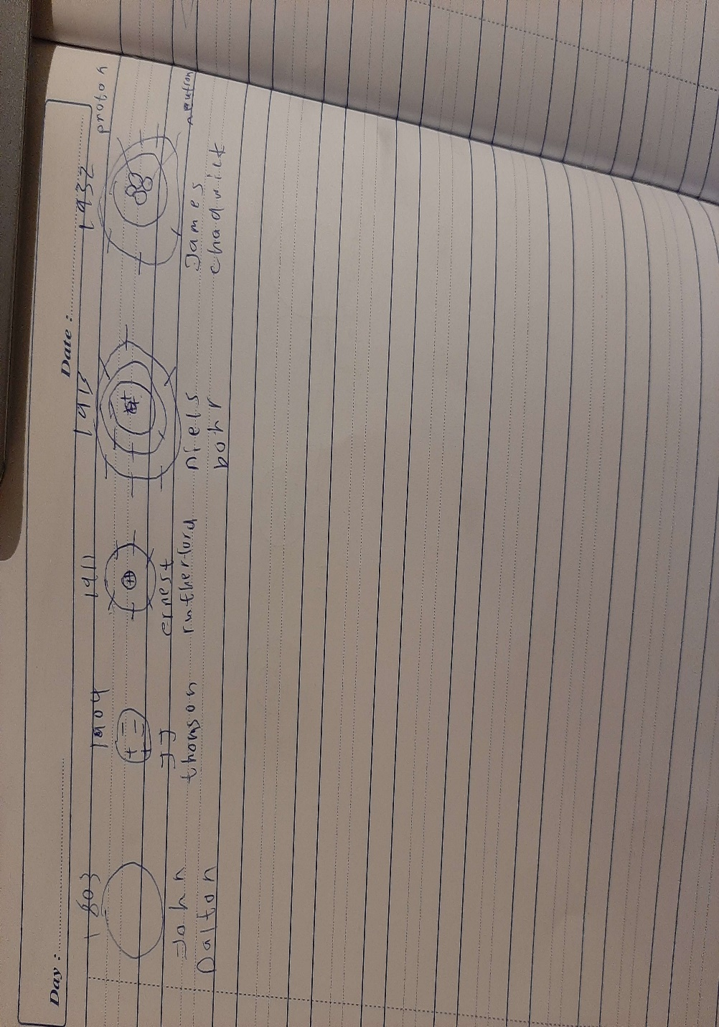

Main Courses

• Write the main points in Dalton’s atomic model.

Atoms of a given element are identical in size, mass, and other properties. Atoms of different elements differ in size, mass, and other properties. Atoms cannot be subdivided, created, or destroyed.

• How has the atomic structure changed by time? (write between 80-100 words)

The structure of an atom contains a center called a nucleus which contains protons and neutrons. The electrons revolve around the nucleus in a circular orbit with fixed energy and velocity. There are so many assumptions related to the structure of atoms which are changed with the time.  
The first theory of atomic structure was proposed by John Dalton in 1800. The Dalton atomic theory says that the atom is the smallest fundamental particle which cannot be further subdivided. The atoms of different elements are different.  
As Dalton atomic theory had some drawbacks. The atomic model was then modified by J.J Thomson. The J.J Thomson says that the atom is made up of positive charge and the electrons are embedded like plum pudding.  
After the J.J Thomson model, Bohr’s atomic model is proposed. He said that an atom has the center called a nucleus where electrons revolve around the nucleus. During the revolution the electrostatic force is generated between the nucleus and electrons. During the revolution, electrons neither gain nor lose energy.  
After the Bohr model, Rutherford model was proposed known as alpha scattering model. He discovered nucleus and discovered that electrons move in circular orbit. Some atoms are hollow. The number of protons is the same as the number of electrons.

• What is the importance of the atomic structure? (write between 80-100 words)

By learning about atomic structure, we can find out how atoms combine and form many compunds. By learning about atomic structure, we can find out how atoms collide. By learning about atomic structure, we can find out why atoms do not have mass. By learning about atomic structure, we can find out how atoms disappear. the atom is the fundamental building block of chemical structures. Atoms are **the smallest building blocks of matter and make up everything around us.**

# Deserts

# • Draw a timeline detailing the important events and scientists in the history of the Atomic Model.

# • Create a timeline poster

# 