What is an atom?  
Atoms are tiny particles that make up all material around us.  
material: Element/Mixture/Compound.  
  
According to Dalton’s theory   
1-All material is made up of tiny particles atom.  
2-Atoms of an element are all the same.  
3-Different elements have different types of atoms.  
  
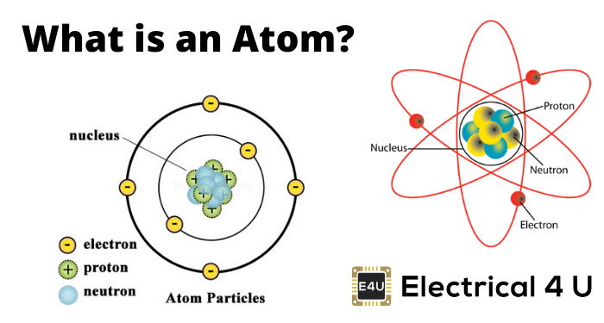  
1-Nucleus same word  
2-orbits level energy   
3-sub-atomic particles shell  
 orbits  
A-Protons  
B-Neutrons inside the nucleus   
C-Electrons orbiting around the nucleus  
  
Proton number:-it is the number of protons inside the atom  
the atomic number is the same as the proton number  
  
In pure elements, the number of protons is the same as the number of electrons.  
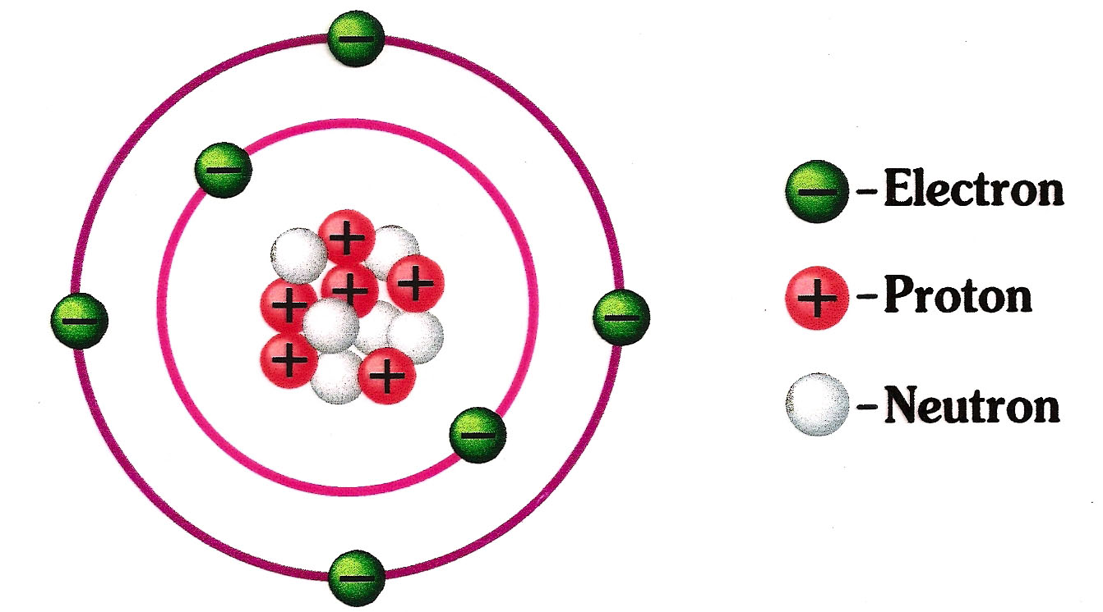  
Neutrons-proton=toghather mass number   
  
atomic number   
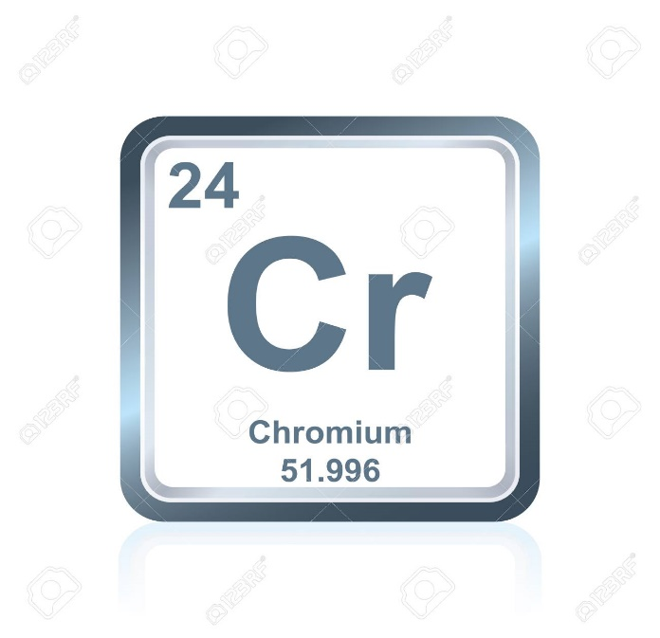  
  
  
mass number  
  
the bugger number is a mess of number  
the less number is the atomic number  
  
  
The mass number is the atom's total amount of protons and neutrons.  
mass number=p+n  
 period group  
  
  
  
 discovery of the nucleus  
  
  
top view of most of the there must  
the atoms atom is an be something solid  
in gold foil empty space side the atom  
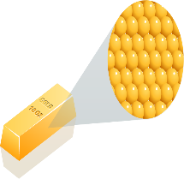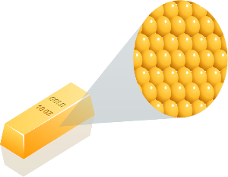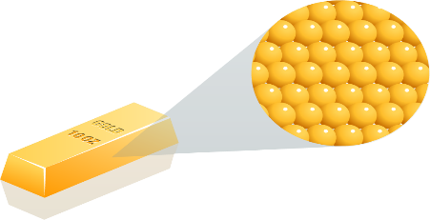  
  
  
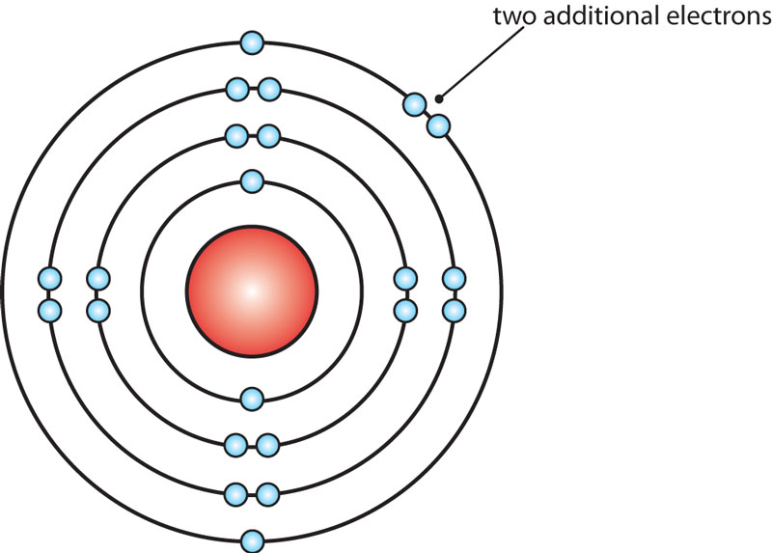  
NOTE  
atomic configuration   
the way electrons are arranged in the orbit.  
Each orbit has a max number of electrons.  
1st orbit =holds up to 2e  
2nd orbit =holds up to 8e  
3rd orbit =holds up to 8e  
4th orbit =holds up to 10e  
for ex.  
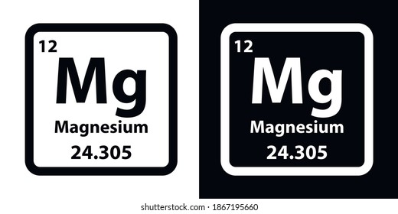  
2,8,2  
  
  
element e #orbit 3e in the outer shell  
Ne 2,8,7 2 8 G8P2  
Si 2,8 3 4 G4P3   
Ca 2,8,8,2 4 2 G2P4  
Be 2,2 2 2 G2P2   
He 2 1 2 G8P1