**The National Orthodox School /Shmaisani**

**Subject: Chemistry**

**Name: Topic: States of matter**

**Date: Grade-Section: 6CS- all sections**



Starters

* Use the particle model to describe solid, liquids and gases and to explain the properties of solids and liquids.
* Draw particle diagrams of solids and gases to model the arrangement of particles in the different states of matter.

Main course

**CHOOSE ONE DISH**

* Describe the processes of freezing and melting using the particle model and relate the processes to changes in temperature. (write between 50-70 words)
* Make a table and write the difference between boiling and evaporation.

Dessert

**CHOOSE ONE DISH**

* Draw the process of water cycle.
* Draw a diagram that shows the changes in states and write the names of the processes on the arrows. (be creative)
* **Use the particle model to describe solid, liquids and gases and to explain**

**gas**

* **the properties of solids and liquids**.

**Solids**

**Liquid**

**Solid: In the solid state the particles touch each other in a certain pattern**

**Liquid: In the liquid state the particles touch but they move around freely not in a certain pattern**

**Gas: In the gas state the particles are FAR apart and they move very fast and in all directions**

* **Describe the processes of freezing and melting using the particle model and relate the processes to changes in temperature. (write between 50-70 words)**

**Melting**

**(ice cube melting)**

**Freezing**

**(ice cube frozen)**

For freezing: When a liquid is frozen the liquid changes from a liquid to solid form this is called **freezing.**

if you want a liquid to freeze the temperature should be 0° to freeze for example if you want to freeze a liquid you put it in the freezer at 0° the next day it will become a solid

For melting: Melting is the process of when a solid tuns to **liquid**

If you want a solid to melt you must put it out in the heat after some time you will find out that it melted from the heat *for example I froze an ice cube and then I let it out to see what was going to happen after a bit I went back to check all I saw was a pile out water from the ice cube*





Then the clouds get full of water (condensation)



Then all the water from the clouds get empty after raining (precipitation)

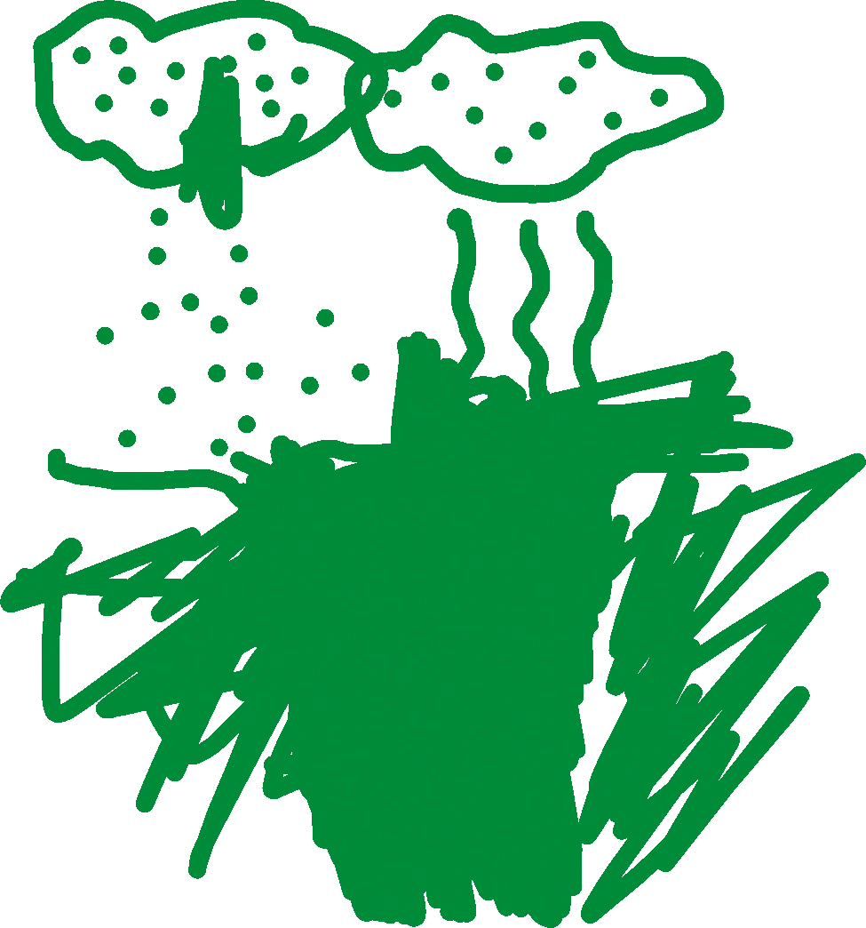

Step one evaporation

