**The National Orthodox School /Shmaisani**

**Subject: Chemistry**

**Name: Sanad zreiqat Topic: States of matter**

**Date: 28/9/2022 Grade-Section: 6CS- all sections**

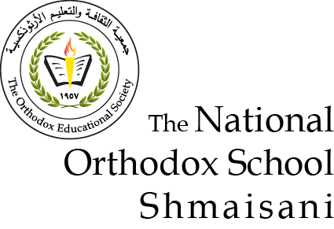

Starters

* Use the particle model to describe solid, liquids and gases and to explain the properties of solids and liquids.
* Draw particle diagrams of solids and gases to model the arrangement of particles in the different states of matter.

1. Solid

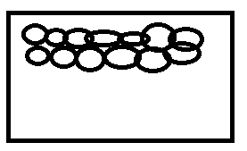

Propertied of solids :

1. Very close to each other
2. Strongly connected
3. Fixed in place and vibrate on the spot
4. Liquid

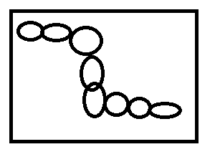

Properties of liquid :

1. The particles touch each other
2. They are not in a pattern
3. Particles move around very fast
4. The particles together strongly
5. Gas

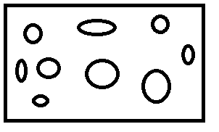

Properties of gas

1. the particles are very far apart
2. They are not in a pattern
3. Particles move around very fast
4. The particles do not hold strongly together

Main course

**CHOOSE ONE DISH**

* Describe the processes of freezing and melting using the particle model and relate the processes to changes in temperature. (write between 50-70 words)
* Make a table and write the difference between boiling and evaporation.

|  |  |  |  |
| --- | --- | --- | --- |
| Process | Change of state | Temperature | How particles leave the liquid |
| Evaporating | From liquid to gas | Happens at any temperature | Partials leave the liquid surface |
| Boiling | From liquid to gas | Happens at boiling point | Bubbles of the substance in gas state from everywhere in the liquid ;the bubbles rise to the surface and escape |

Dessert

**CHOOSE ONE DISH**

* Draw the process of water cycle.
* Draw a diagram that shows the changes in states and write the names of the processes on the arrows. (be creative)

