**Name: Sura Moustafa Homework: Food webs**

**Date: Grade-Section: 6 CS – All Sections**

**Objective: Identify the parts of a food chain and food web.**

**Question One:**

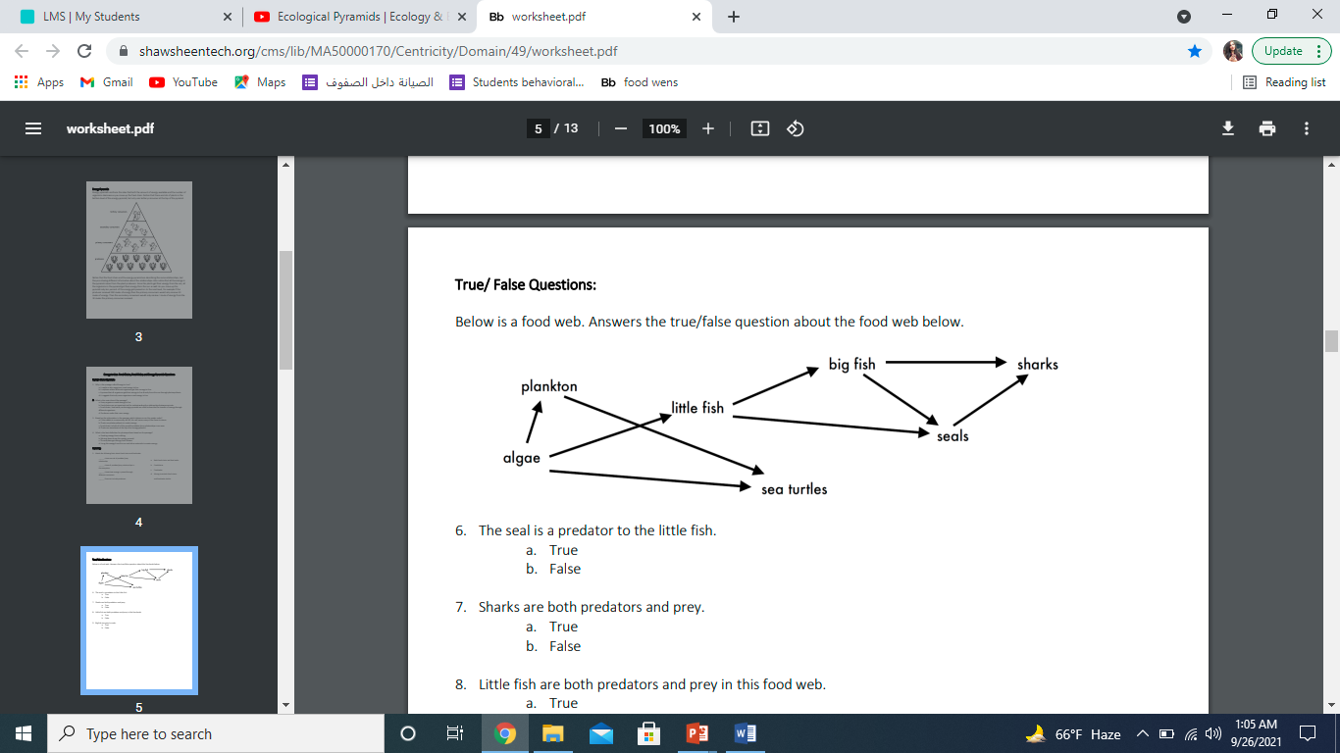Answer the following questions about the food web below.

1. The big fish is a predator to the Sharks and Seals.
2. Which animals would have a bigger food supply if the number of little fish decreased? Big fish and Seals.
3. Which organism would have the least biomass in this food web? Sharks.
4. Sharks are both predators and prey.

a. True

b. False

1. Decomposers are very important for life on Earth.

Explain what is the role of decomposers in food webs.

Decomposers break down the dead animals and animal droppings and return the nutrients back to the soil.

________________________________________________________________________