**The National Orthodox School /Shmaisani**

**Subject: Chemistry**

**Name: Sura Moustafa Topic: States of matter**

**Date: Grade-Section: 6CS- all sections**

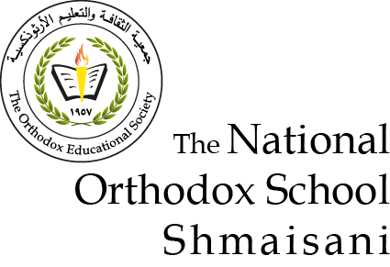

Starters

* Use the particle model to describe solid, liquids and gases and to explain the properties of solids and liquids.
  + Solid: Particles are very strongly holding each other. They vibrate in place.
  + Liquid: particles are strongly holding together. They slid over each other.
  + Gas: particles are far apart from each other. They flow over each other.
* Draw particle diagrams of solids and gases to model the arrangement of particles in the different states of matter.



Main course

**CHOOSE ONE DISH**

* Describe the processes of freezing and melting using the particle model and relate the processes to changes in temperature. (write between 50-70 words)
* Make a table and write the difference between boiling and evaporation.

|  |  |
| --- | --- |
| **Boiling** | **Evaporation** |
| Bubbles are formed | Bubbles are NOT formed |
| Happens in all the liquid | Happens at the surface of the liquid |
| Happens at boiling point | Happens at any temperature |
| Happens fast | Happens slowly |

Dessert

**CHOOSE ONE DISH**

* Draw the process of water cycle.
* Draw a diagram that shows the changes in states and write the names of the processes on the arrows. (be creative)

