**Subject: Chemistry**

Aoun Qsous

The National Orthodox School /Shmaisani

**Name: Topic: States of matter**

29/9/2022

**Date: Grade-Section: 6CS- all sections**



Starters

* Use the particle model to describe solid, liquids and gases and to explain the properties of solids and liquids.
* Draw particle diagrams of solids and gases to model the arrangement of particles in the different states of matter.

Main course

**CHOOSE ONE DISH**

* Describe the processes of freezing and melting using the particle model and relate the processes to changes in temperature. (write between 50-70 words)
* **Make a table and write the difference between boiling and evaporation.**

Dessert

**CHOOSE ONE DISH**

* Draw the process of water cycle.
* Draw a diagram that shows the changes in states and write the names of the processes on the arrows . (be creative)

**Q1 Use the particle model to describe solid, liquids and gases and to explain the properties of solids and liquids.**

* Solids have particles that are strongly attached together usually in a pattern and in a fixed shape, solids cannot be compressed, and it has a fixed volume, and a fixed mass. Solids move by vibration.
* Liquids have particles that still touch and are close together but the spaces between the particles are large enough that allow the particles to slide past each other. it doesn’t have a fixed shape but rather it takes the shape of the container it’s in by starting from the bottom to the top, liquids can be compressed a little bit, and it has a fixed volume, and a fixed mass. Liquids move by flowing, and it doesn’t have a pattern.
* Gases have particles that are spread apart from each other, gases don’t have a fixed shape nor a fixed volume, but it has a fixed mass, and it takes the shape of the container it’s in, and it can flow, but unlike liquids it takes the shape of the whole container it moves around randomly, also it can be compressed furthermore it doesn’t have a pattern

**Q2 Draw particle diagrams of solids and gases to model the arrangement of particles in the different states of matter**

**Can occur at any/all tempertures**

**Occurs at a fixed temperture/ boiling point**

**Only occars from the visble surface of the liquid**

**Throughout the entire liquid**

**There are no air bubbles**

**There are lots of air bubbles**

**It is a quick process**

**It is a slow process**

**Evaporation**

**Boiling**

**Q3 Make a table and write the difference between boiling and evaporation.**

**Gases particles**

**Solids particles**

**Heat supplied by an energy/heat source.**

**Heat supplied by the surroundings**.

**Q4 Draw a diagram that shows the changes in states and write the names of the processes on the arrows**

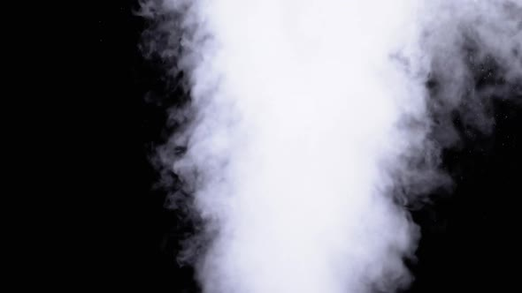

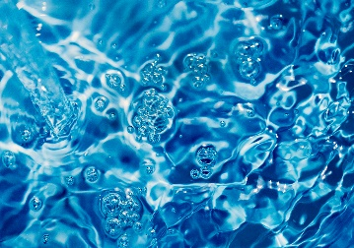

Freezing

Condensation

Evaporation

Melting

Desubilmation

Subilmaton

