**Name: Homework: Food webs**

**Date: Grade-Section: 6 CS – All Sections**

**Objective: Identify the parts of a food chain and food web.**

**Question One:**

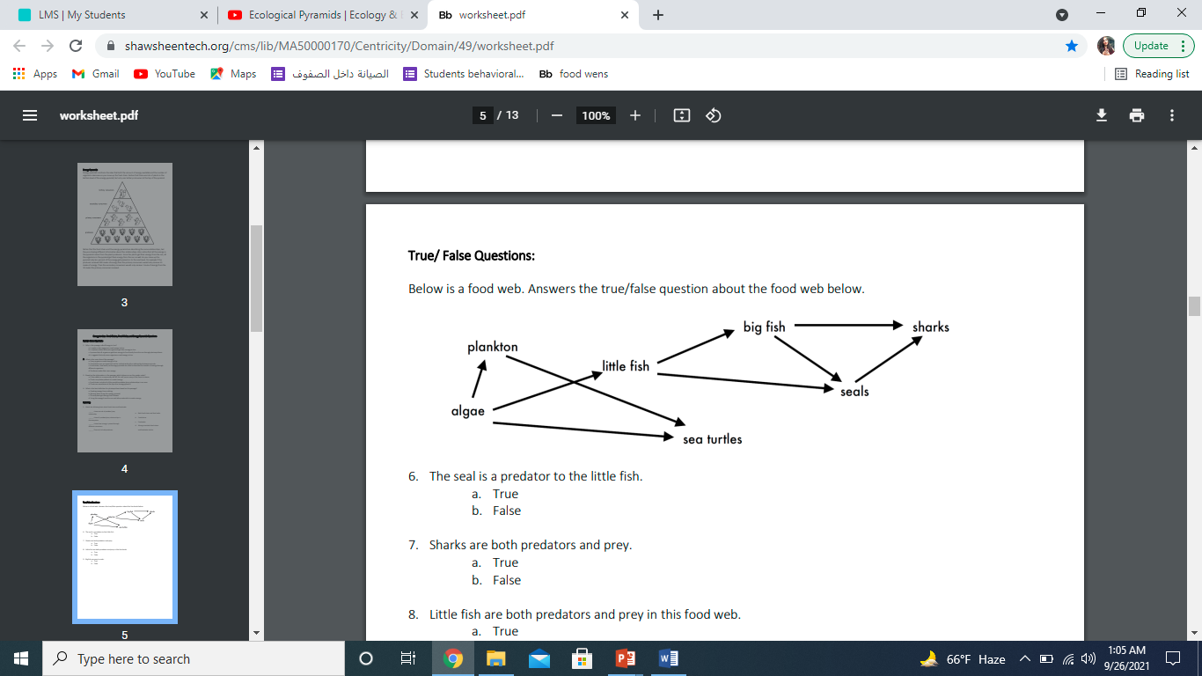Answer the following questions about the food web below.

1. The big fish is a predator to the little fish_____.
2. Which animals would have a bigger food supply if the number of little fish decreased? _____________________shark_____.
3. Which organism would have the least biomass in this food web? _________sharks______.
4. Sharks are both predators and prey.
5. True

b. False

1. Decomposers are very important for life on Earth.

Explain what is the role of decomposers in food webs.

____decomposers brake down food and return nutrients to the soil____________________________________________________________________