**Development of the structure of the atom homework**

1. Dalton, Thomson, Rutherford
2. 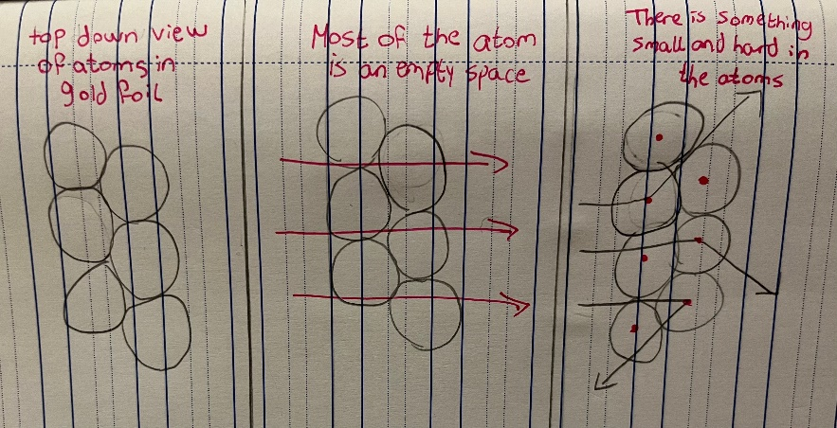
3. Write the main points in Dalton’s atomic model:

The first point is that all matter is made of atoms, his second point was that all atoms of a given element are identical in mass and properties, his third point was Atoms of different elements show different properties, and they have different masses and different chemical properties, and his fourth point was that Compounds are formed by a combination of two or more different kinds of atoms.

4.How has the atomic structure changed by time:

In the early 19th century Dalton all matter has atoms, he thought that the atom was an empty ball-like structure. In 1897 Thomson suggested his plum pudding model he said it was positively charged with electrons distributed throughout the atom, in 1911 a scientist name Rutherford conducted the gold foil experiment he shot Alpha particles toward a thin sheet of gold foil that was surrounded by a belt which would allow detection of the deflected particles, after this experiment his results concluded that the atom is mostly empty space with a tiny, dense, positively-charged nucleus.