**Name: Homework: Food webs**

**Date: Grade-Section: 6 CS – All Sections**

**Objective: Identify the parts of a food chain and food web.**

**Question One:**

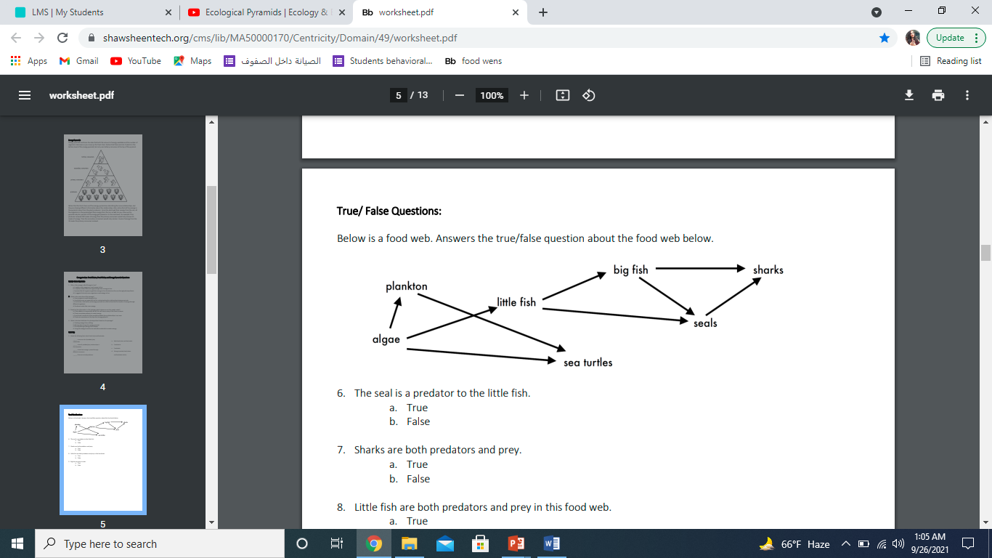Answer the following questions about the food web below.

1. The big fish is a predator to the ____seals, sharks____.
2. Which animals would have a bigger food supply if the number of little fish decreased? ______big fish__
3. Which organism would have the least biomass in this food web? Little fish
4. Sharks are both predators and prey.

a. True

b. False

1. Decomposers are very important for life on Earth.

Explain what is the role of decomposers in food webs.

decomposers break down the bodies of plants and animals and return mineral nutrients to the soil