Starters

The solid state:

* The particles touch each other.
* The particles are in fixed positions in a regular pattern.
* The particles vibrate on the spot.
* The particles hold very strongly together.

The liquid state:

* The particles touch each other.
* They are not in a pattern.
* The particles hold strongly.
* The particles move around randomly sliding over each other.

The gas state:

* The particles are far apart.
* They are not in a pattern.
* The particles move around very fast in all directions.
* The particles do not hold together strongly

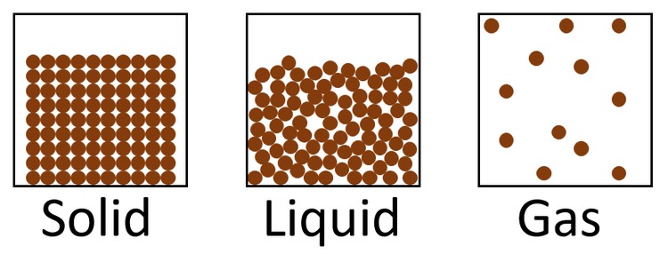

Main course

|  |  |  |  |
| --- | --- | --- | --- |
| Process | Change of state | Temperature | How particles leave the liquid |
| Evaporating | From liquid to gas | Happens at any temperature | Particles leave the liquid surface |
| Boiling | From liquid to gas | Happens at the boiling point | Bubbles of the substance in the gas state form liquid; the bubbles rise to the surface and escape |

Dessert

Ice

cloud

Water

Evaporates

Melts

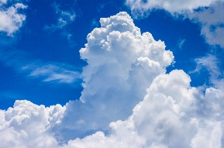

Freezes

Condenses