Sima Najjar

Sima Najjar a Jordanian female passionate about online businesses, mother of three, and the founder of “how to videos” in Arabic “eKeif”.

Sima started her YouTube journey in 2012, with over 1,000 videos uploaded, Sima was able to attract more than 85 million viewers with approximately 500k subscribers.

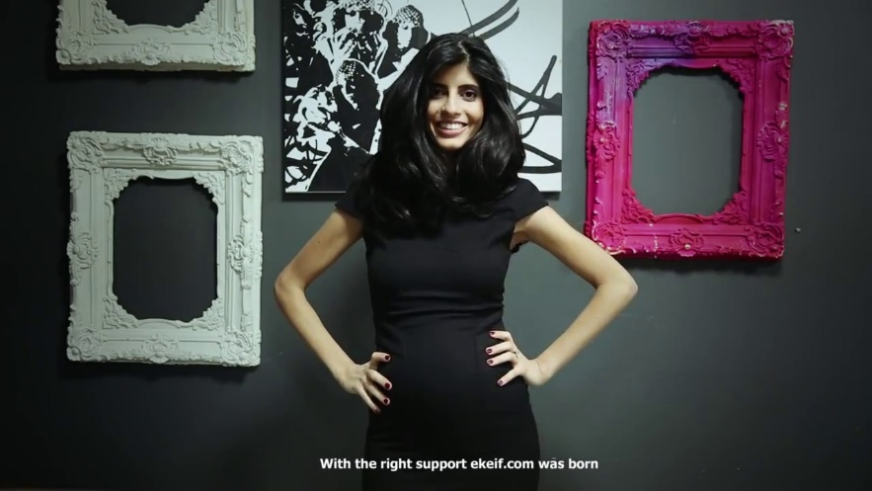Sima’s content provided help for young parents with cooking, lifestyle, arts and crafts and more. Her content filled a void in the local market with easy and quick Arabic edutainment videos that address common asked questions and offer do-it-yourself advice for her viewers, not that she doesn’t know or like English, in fact she was fluent in it but since every how to video is in English she decided to make some for her Arabic speaking viewers.

Here are some of her great accomplishments:

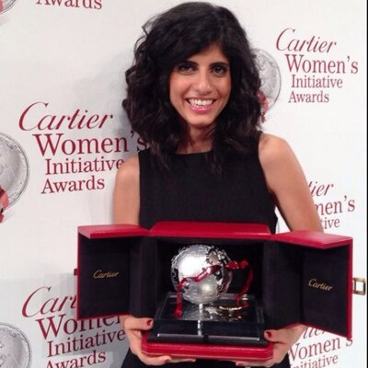 Sima was awarded the Cartier Women's Initiative Awards for the Middle East region for her Ekeif project in October 2013.

Sima attended in the Mount Kilimanjaro Climbing Team in 2014 and helped raise money and awareness for the King Hussein Cancer Center. Together, they were successful in earning $ 1.6 million. Sima continued ascending despite being blinded by snow for 48 hours in order to reach the summit with the crew.

In 2019 she launched a series of tangible toys for children.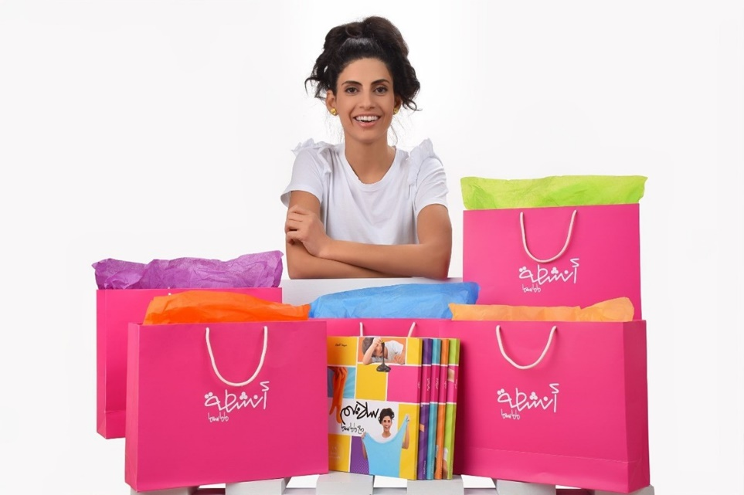In 2022, Sima launched "Mamasima Activities" an Arabic book series consisting of 5 books: Sensory Play with Mamasima, Playdough with Mamasima, Slime with Mamasima, Color Mess with Mamassima, Science Experiments with Mamasima, it has more than 120 activities followed by easy and fun videos Using substances available at home.