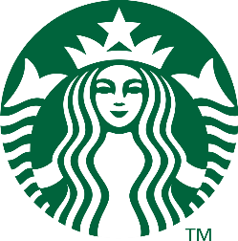 Starbucks

Have you ever ask yourself who created Starbucks? If you do not know what Starbucks is, I will talk to you about it.

Starbucks Corporation is an American multinational chain of coffeehouses and roastery reserves headquartered in Seattle, Washington. It is the world's largest coffeehouse chain. As of November 2021, the company had 33,833 stores in 80 countries, 15,444 of which were located in the United States.

The founders of Starbucks are Gordon Bowker, Jerry Baldwin and Zev Siegl.

Gordon Bowker is an American writer, businessperson and entrepreneur most well known for being the founder of Starbucks. He died on January 14, 2019. Zev Siegl was born on December 28, 1942. He is a businessperson. Jerry Baldwin is a winemaker.

Their passion was building a company that treats the people with dignity and respect.

By Alba Luna 6b