Howard Schultz

Who is Howard Schultz?

*Howard D. Schultz (born July 19, 1953) is an American businessman and author who served as both chairman and CEO of Starbucks from 1986 to 2000, from 2008 to 2017, and as interim CEO since 2022. Schultz also owned the Seattle Supersonics basketball team from 2001 to 2006.*

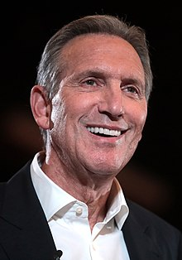

What was his passion?

***he's passionate about the people, the baristas who make the Starbucks experience what it is***.

How did he start his business?

***Schultz began working at the coffeehouse Starbucks in 1982. He later left and opened Il Giornale, a specialty coffeeshop, that merged with Starbucks during the late-1980s. Under Schultz, the company established a large network of stores which has influenced coffee culture in Seattle, the U.S., and internationally. Following large-scale distribution deals Starbucks became the largest coffee-house chain in the world. Schultz took the company public in 1992 and used a $271 million valuation to double their store count in a series of highly publicized coffee wars. He stepped down as CEO in 2000, succeeded by Orin Smith.***

***Thank you for reading 😊***