**Name: Rayan Samawi Homework: Food webs**

**Date: 27l9l2022 Grade-Section: 6 CS – All Sections**

**Objective: Identify the parts of a food chain and food web.**

**Question One:**

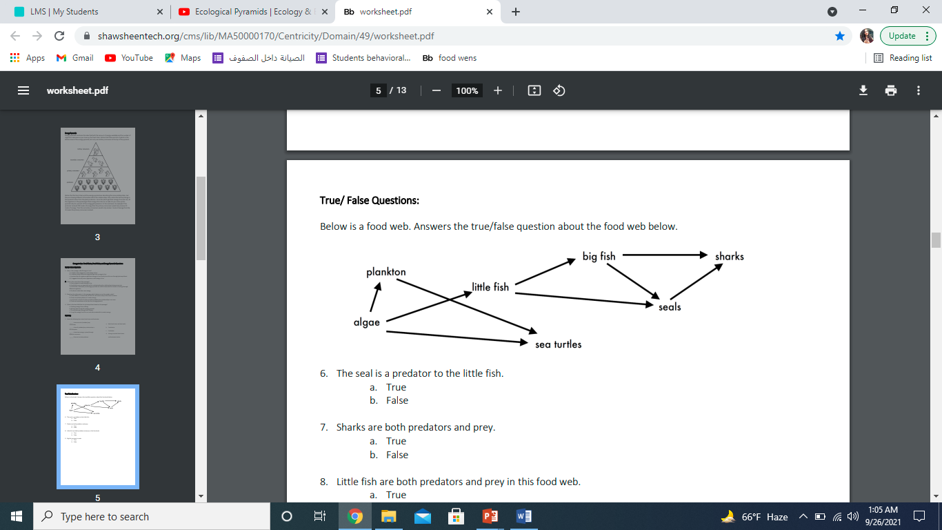Answer the following questions about the food web below.

1. The big fish is a predator to the SHARKS
2. Which animals would have a bigger food supply if the number of little fish decreased? PLANKTON
3. Which organism would have the least biomass in this food web? SHARKS.
4. Sharks are both predators and prey.

a. True

b. False

1. Decomposers are very important for life on Earth.

Explain what is the role of decomposers in food webs.

They eat the remains of dead animals they break down the waste and remains into simple chemicals and nutrients. These chemicals can be used again by other living things.

.