Dragonfly Chaser

By Abdullah Khattab 6C

This is version 2 of my work( I added the optional part).

Dragonfly coding:

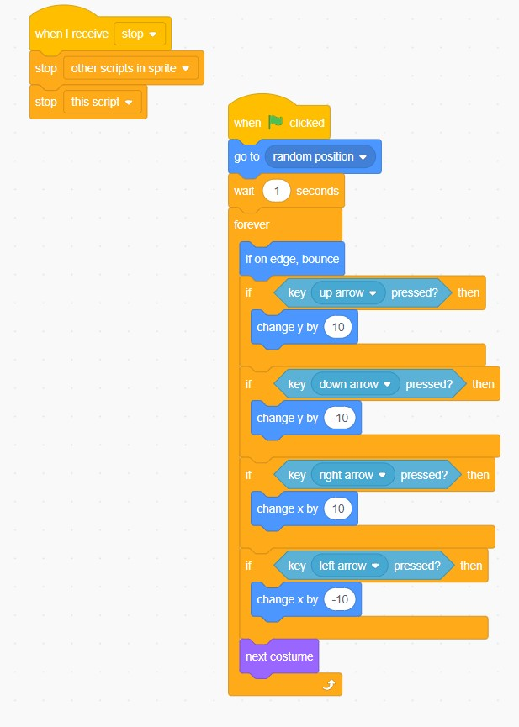

Balloon coding:

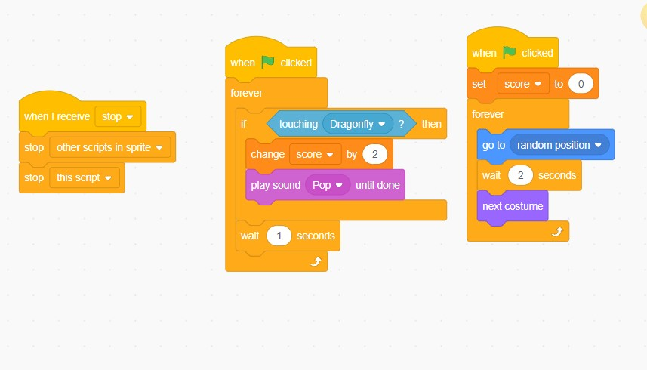

I made the stop button and clicking it will stop the game (you can find it on the top right corner of the screen) here is the coding:

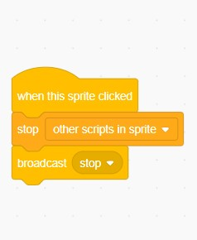

I also added the win screen get to 40 points to win, here is the coding:

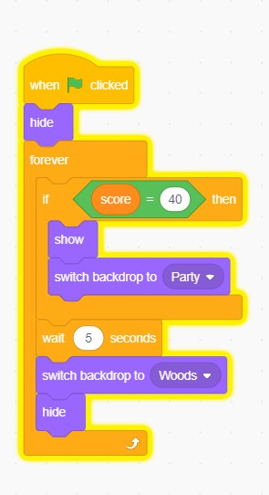

Here is the game

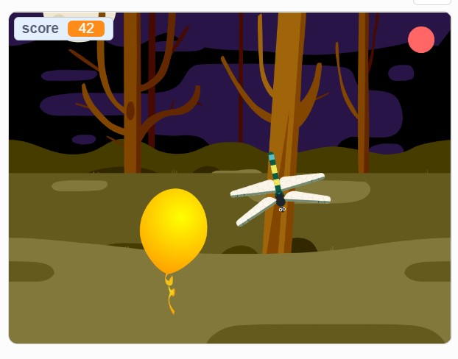 

Here is the link to the game:

<https://scratch.mit.edu/projects/737215910>