**The National Orthodox School /Shmaisani**

**Subject: Chemistry**

**Name: Karmel Topic: States of matter**

**Date: 26.9.2022 Grade-Section: 6CS- all sections**



Starters

* Use the particle model to describe solid, liquids and gases and to explain the properties of solids and liquids.
* Draw particle diagrams of solids and gases to model the arrangement of particles in the different states of matter.

Main course

**CHOOSE ONE DISH**

* Describe the processes of freezing and melting using the particle model and relate the processes to changes in temperature. (write between 50-70 words)
* Make a table and write the difference between boiling and evaporation

Dessert

**CHOOSE ONE DISH**

* Draw the process of water cycle.
* Draw a diagram that shows the changes in states and write the names of the processes on the arrows. (be creative)

1. Use the particle model to describe solid, liquids and gases and to explain the properties of solids and liquids.

SOLID STATE

In the solid state the particles touch each other the particles are in fixed positions in a regular pattern the particles vibrate on the spot the particles hold together strongly.

Shape stays the same unless you apply a force.

LIQUID STATE

In the liquid state the particles touch each other they are not in a pattern the particles move around randomly sliding over each other the particles hold together strongly.

It takes the shape of the bottom of its container.

GAS STATE

In the gas state the particles are far apart they are not in pattern the particles move around very fast in all directions the particles do not hold together strongly.

It takes the shape of the whole container.

1. Draw particle diagrams of solids and gases to model the arrangement of particles in the different states of matter.

SOLID

Liquid

c

GAS

3- Make a table and write the difference between boiling and evaporation

|  |  |
| --- | --- |
| Evaporation | Boiling |
| A process in which a substance change its state from liquid to gas without boiling | A process in which a substance change its state from liquid to gas |
| Slow | Fast |
| No bubbles formed | Bubbles are formed |
| Takes place only from the exposed surface of the liquid | Occurs throughout the liquid |
| Occurs at all temperatures | Occurs at a definite temperature boiling point |

4- Draw the process of water cycle

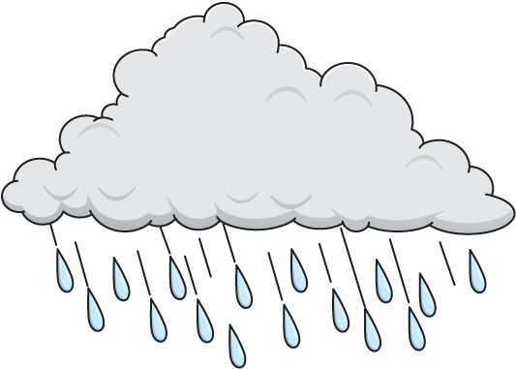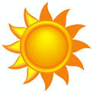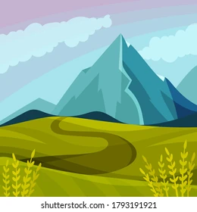

Water cycle

condensation

precipitation

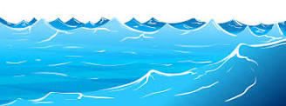evaporation