Chemistry

1. All matter is made of tiny particles:

|  |  |  |
| --- | --- | --- |
| solid | liquid | gas |
| Particles are packed together | Particles are close to each other | Particles are far apart |
| particles vibrate in there place | Particles slide over each other | Particles move freely |
| Strong force between particles | Low force between particles | Very weak force between particles |

2)

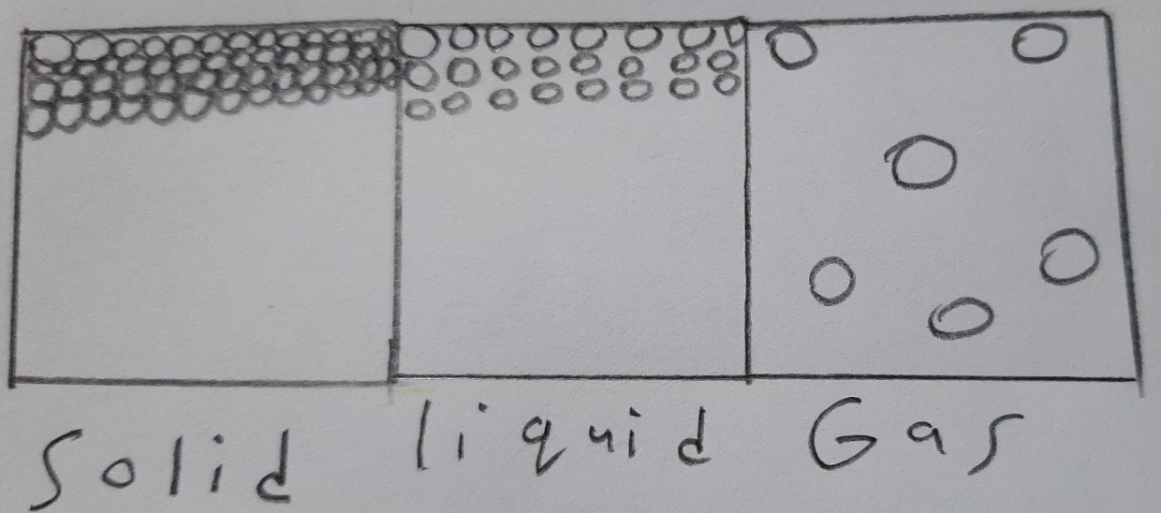

3)

|  |  |
| --- | --- |
| Boiling | Evaporation |
| Fixed temperature | Freezing Temp < Evaporation Temp (any temp) < Boiling Temp |
| All liquid | On the surface |
| Forms bubbles | No bubbles |

4)

