**The National Orthodox School /Shmaisani**

**Subject: Chemistry**

**Name: Topic: States of matter**

**Date: Grade-Section: 6CS- all sections**

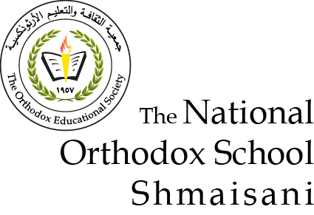

Starters

* Use the particle model to describe solid, liquids and gases and to explain the properties of solids and liquids:solids/gasses/liquids.solides are particals stuck to each other in a pattern.liquids are particals that touch eachother but they have more energy so they move,gases form when the particals never thouch and they move alot

Main course

**CHOOSE ONE DISH**

* Describe the processes of freezing and melting using the particle model and relate the processes to changes in temperature. (write between 50-70 words):melting and freezing have the same procces temperature at 0c freezing id when the particals in water or other liquid lose energy and then it turns into solid and when you melt the ice it gains energy when it becomes a liq