**Name: Homework: Food webs**

**Date: Grade-Section: 6 CS – All Sections**

**Objective: Identify the parts of a food chain and food web.**

**Question One:**

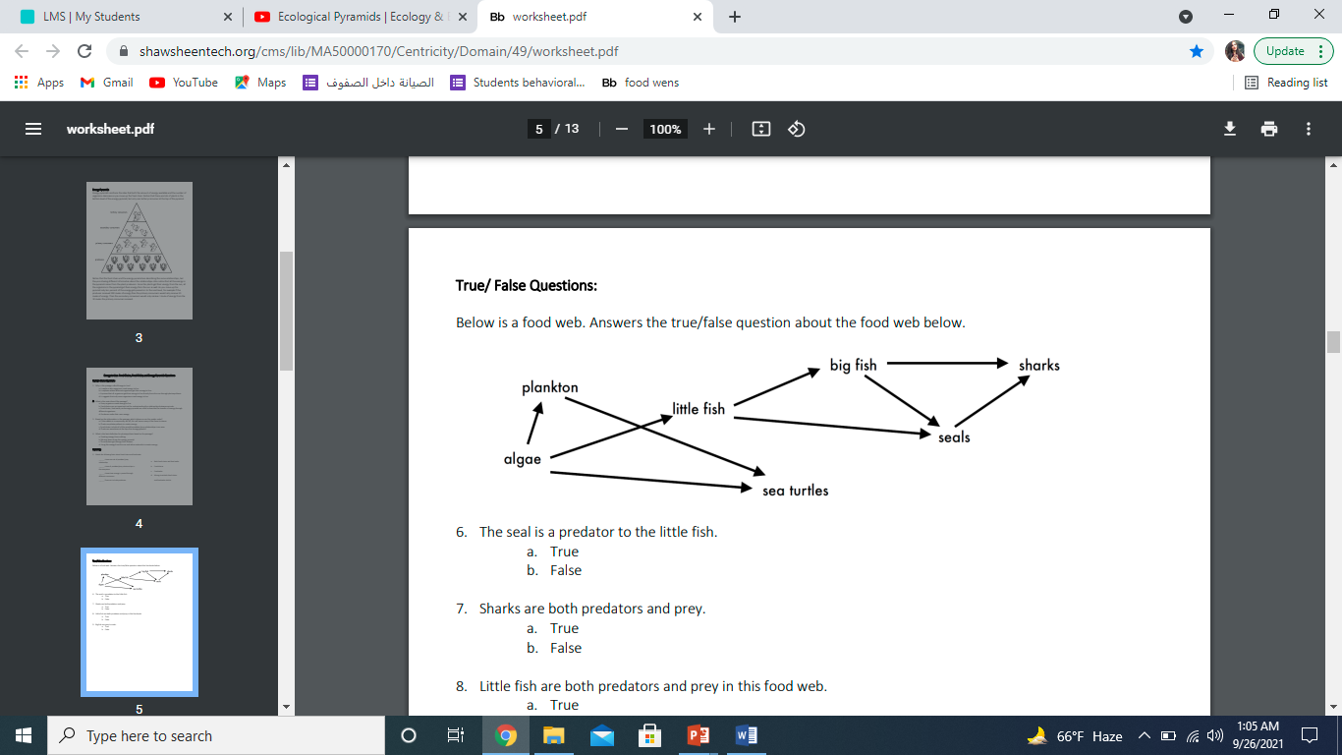Answer the following questions about the food web below.

1. The big fish is a predator to the **____little fish____.**
2. Which animals would have a bigger food supply if the number of little fish decreased? **__sea turtles and plankton__.**
3. Which organism would have the least biomass in this food web? **__sharks___.**
4. Sharks are both predators and prey.

a. True

**b. False**

1. Decomposers are very important for life on Earth.

Explain what is the role of decomposers in food webs.

**Decomposers decompose dead animals plant and fruit when broken down nutrions reach the soil and help new plant grow**