**Starters**

* Use the particle model to describe solid, liquids and gases and to explain the properties of solids and liquids.

|  |  |  |
| --- | --- | --- |
|  |  |  |
| Particles are packed closely together (Like) | Particles are still closed together but not like solid (Like) | Particles are far away from each other (Like) |
| Particles are arranged in ordered rows (Arranged) | Particles are randomly arranged (arranged) | Particles are randomly arranged (Arranged) |
| Particles are not moving unless vibration (Move) | Particles are free to move around each other (Move) | Particles are free to move in different direction and move quickly (Move) |
| Particles are too close to each other (Far) | Particles are close but too much like solids (Far) | Particles are far away from each other (Far) |
| Particles are strongly hold together (Strongly) | Particles are hold to each other but not strongly as solids (Strongly) | Particles are free and far apart (strongly) |

* Draw particle diagrams of solids and gases to model the arrangement of particles in the different states of matter.

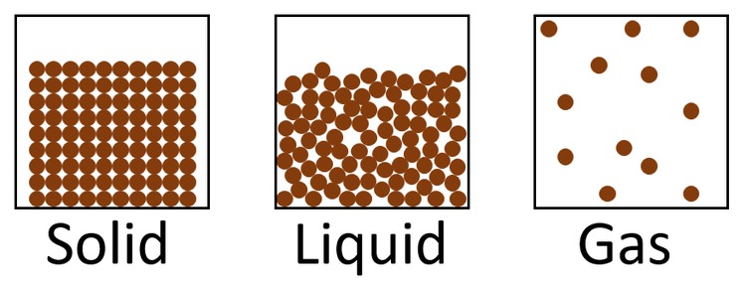 

**Main Course**

* Describe the processes of freezing and melting using the particle model and relate the processes to changes in temperature. (Write between 50-70 words)

**Decreasing Temperature**

**Increasing Temperature**

Melting is the process by which a solid change to a liquid as the temperature increases. The point at which a solid material become liquid is called the melting point. Melting occurs when the internal energy of the solid rises, typically by heat, which increases the substance's temperature to the melting point.

Freezing is the process by which a liquid turns into a solid as the temperature decrease. The point at which a liquid material become a solid is called the feezing point. This is, in most substances, the same as the melting point.

Freezing is a reversible change: this means that once something is frozen, it can revert to its original liquid state.

**Dessert**

* Draw a diagram that shows the changes in states and write the names of the processes on the arrows. (Be creative)

