**The link for the scratch dragonfly game**

<https://scratch.mit.edu/projects/736695468>

**The dragonfly code**

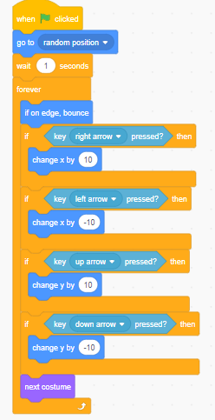

**The balloon code**

