**The National Orthodox School /Shmaisani**

**Subject: Chemistry**

**Name :Rita Topic: States of matter**

**Date: Grade-Section: 6CS- all sections**

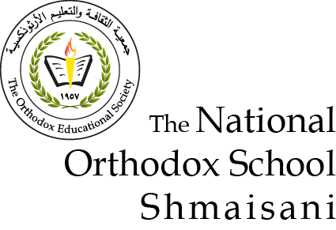

Starters

w

* Use the particle model to describe solid, liquids and gases and to explain the properties of solids and liquids.
* Draw particle diagrams of solids and gases to model the arrangement of particles in the different states of matter.

Main course

**CHOOSE ONE DISH**

* Describe the processes of freezing and melting using the particle model and relate the processes to changes in temperature. (write between 50-70 words)
* Make a table and write the difference between boiling and evaporation.

Dessert

**chOSE ONE DISH**

* Draw the process of water cycle.
* Draw a diagram that shows the changes in states and write the names of the processes in the arrows. (be creative
* **Question one**

solid liquid gas

|  |  |  |
| --- | --- | --- |
|  |  |  |

solid are regular arranged and gas are randomly arranged

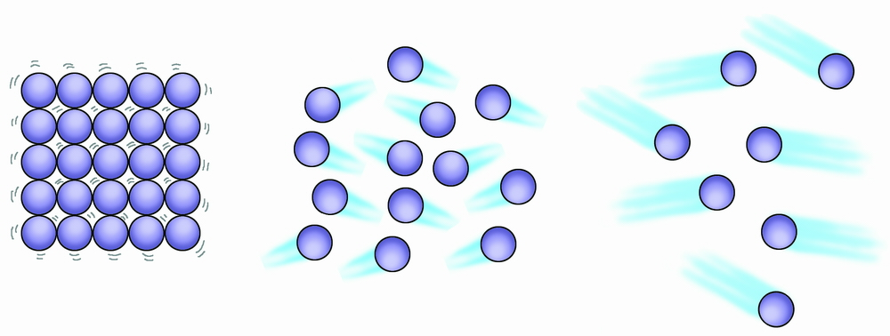 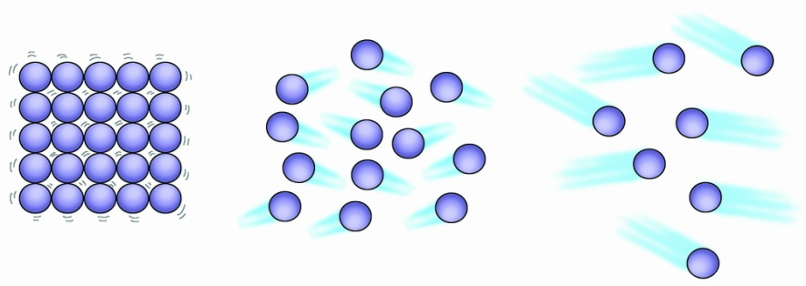

**Question 2**

**Melting /Freezing**

Is changing the phase of substance from a [solid](https://en.wikipedia.org/wiki/Solid) to a [liquid](https://en.wikipedia.org/wiki/Liquid). When the energy of the solid increases, which increases the substance's temperature to the melting point. When the solid starts to melt until it has completely turned into a liquid its temperature doesn’t rise. All the heat energy is used to separate the particles so they can flow over one another. Freezing is a phase transition where a liquid turns into a solid when its temperature is lowered below its freezing point.

**Question 3**

