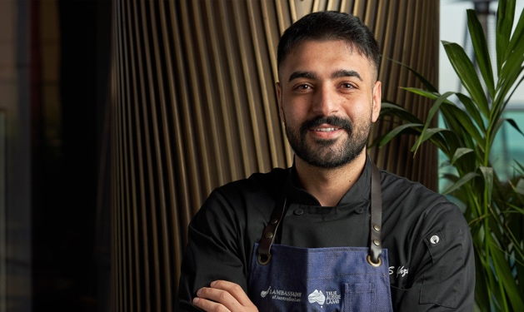**Ali Ghzawi**

***Jordanian Chef***

Ali Ghzawi is the winner of the Top Chef Middle East 2019 and now a famous Jordanian chef.

He began from just selling sandwiches to his classmates in school to discovering his passion for cooking at the age of 17 when he successfully completed his education in the Global Hospitality at the Royal Academy of Culinary Arts.

He started his business by opening three restaurants in Amman. One of his most famous restaurants, called Alee by Ali, located in Jabal Amman. He recruits other chefs and mentors them.

Chef Ali is now renowned as one of the region’s most famous chefs for his age. His cooking journey and skills have developed and improved more and more into a full career, and now with his own restaurants he travels around the world representing his country, Jordan.