Dragonfly Chaser

By Abdullah Khattab 6C

Dragonfly code: Balloon code:

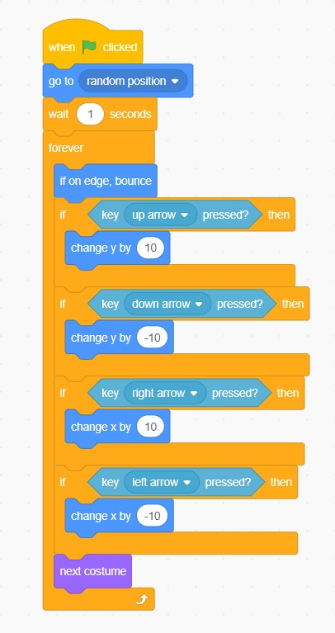 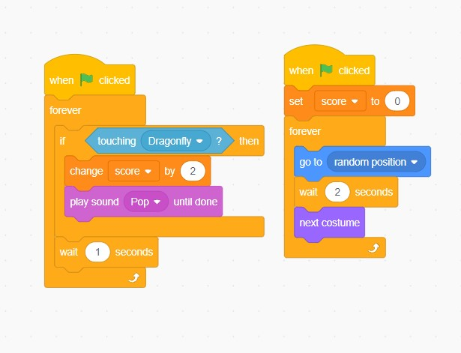

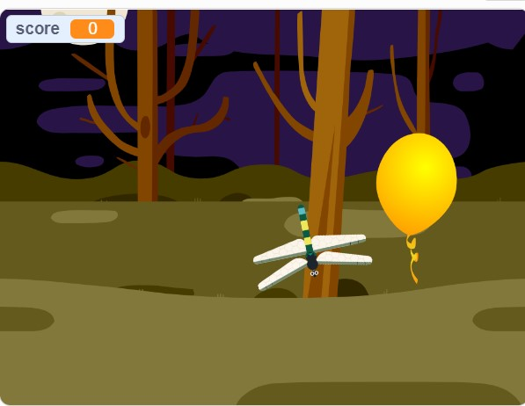

Link to project (copy link to open project):

https://scratch.mit.edu/projects/736640284