**The National Orthodox School /Shmaisani**

**Subject: Chemistry**

**Name: karam Topic: States of matter**

**Date:25/9/2022 Grade-Section: 6CS- all sections 6f**

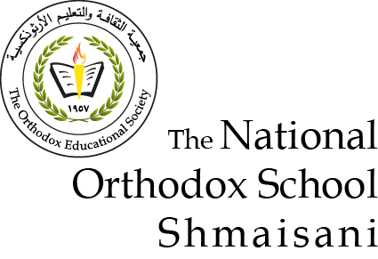

Starters

* Use the particle model to describe solid, liquids and gases and to explain the properties of solids and liquids.

Solid: in a pattern and touching each other.

Liquid: touching each other but not in a pattern.

* Draw particle diagrams of solids and gases to model the arrangement of particles in the different states of matter.

Main course

**CHOOSE ONE DISH**

* Describe the processes of freezing and melting using the particle model and relate the processes to changes in temperature. (write between 50-70 words)
* Make a table and write the difference between boiling and evaporation.

Dessert

**CHOOSE ONE DISH**

* Draw the process of water cycle.
* Draw a diagram that shows the changes in states and write the names of the processes on the arrows. (be creative)