**The National Orthodox School / Shmaisani**

**Subject: Chemistry**

**Name: Sadeen AbuHazeem Topic: States of matter**

**Date: Sep.20th, 2022 Grade-Section: 6CS- all sections**



Starters

* Use the particle model to describe solid, liquids and gases and to explain the properties of solids and liquids.
* Draw particle diagrams of solids and gases to model the arrangement of particles in the different states of matter.

Main course

**CHOOSE ONE DISH**

* Describe the processes of freezing and melting using the particle model and relate the processes to changes in temperature. (write between 50-70 words)
* Make a table and write the difference between boiling and evaporation.

Dessert

**CHOOSE ONE DISH**

* Draw the process of water cycle.
* Draw a diagram that shows the changes in states and write the names of the processes on the arrows. (be creative)

**-Starters**

**Q1) Use the particle model to describe solid, liquids and gases and to explain the properties of solids and liquids.**

**Solid Liquid Gas** -fixed shape -change shape -change shape  
 -fixed volume -fixed volume -change volume  
 -fixed mass -fixed mass -fixed mass  
  
**Q2) Draw particle diagrams of solids and**

**gases to model the arrangement of particles in the different states of matter.**

|  |  |  |
| --- | --- | --- |
| **Solids** | **Liquid** | **Gas** |
| In a regular arrangement | In a random arrangement | In a random arrangement |
| Vibrate in a fixed position | Move around each other | Move fast everywhere |
| Tightly packed | Close | far apart |

**-Main course**  
**Q1) make a table and write the difference between boiling and evaporation.**

|  |  |
| --- | --- |
| **Evaporation** | **Boiling** |
| Doesn’t form bubbles | Forms bubbles |
| Happens at any temperature (room temp) | Happens at the boiling point |
| Slow | Fast |
| At the surface of the liquid | Throughout the liquid |

**-Dessert  
Q2) Draw a diagram that shows the changes in states and write the names of the processes on the arrows. (be creative)  
   
  
  
  
 evaporation melting**

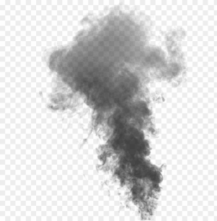 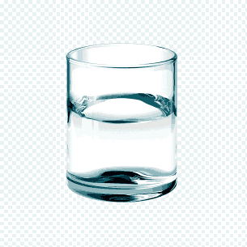 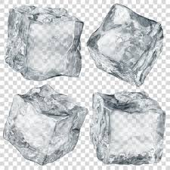

**Condensing freezing**