**The National Orthodox School /Shmaisani**

**Subject: Chemistry**

**Name: Topic: States of matter**

**Date: Grade-Section: 6CS- all sections**

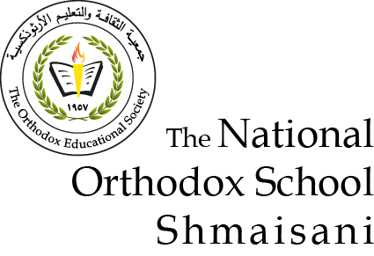

Starters

* Use the particle model to describe solid, liquids and gases and to explain the properties of solids and liquids.

1. Solid state
   1. The atoms are close to and touch each other’s.
   2. They are in a fixed position.
   3. They vibrate on the spot
2. Liquid state
   1. The atoms touch others
   2. Atoms are not in a pattern
   3. Atoms move around randomly
3. Gas state
   1. The atoms are far apart and do not hold on strongly
   2. Not in a pattern
   3. Moves fast in every direction

* Draw particle diagrams of solids and gases to model the arrangement of particles in the different states of matter.

Gas

Liquid

Solids

Main course

**CHOOSE ONE DISH**

* Describe the processes of freezing and melting using the particle model and relate the processes to changes in temperature. (write between 50-70 words)
* Make a table and write the difference between boiling and evaporation.

|  |  |
| --- | --- |
| Boiling | Evaporation |
| * Changes the state of substance from liquid to gas | * Changes the state of substance from liquid to gas |
| * Happens at boiling point | * Happens at any temperature |
| * The bubble of gas rises to the surface and escape | * Particles leave the liquid surface |

Dessert

**CHOOSE ONE DISH**

* Draw the process of water cycle.
* Draw a diagram that shows the changes in states and write the names of the processes on the arrows. (be creative)

Boils/ Evaporates

Melts

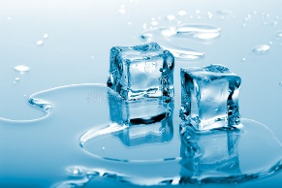 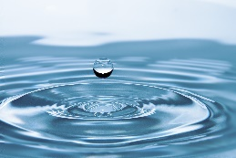 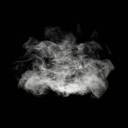

Gas

Liquid

Solid

Condenses

Freezes