Q1:

|  |  |  |  |
| --- | --- | --- | --- |
| proporties | solid | liquid | gas |
| shape | fixed | change | change |
| volume | fixed | fixed | change |
| mass | fixed | fixed | fixed |

Q2:

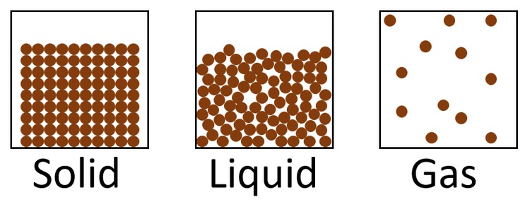

Q3:

|  |  |
| --- | --- |
| boiling | evaporation |
| A process in which a substance changes its state from liquid to gas. | A process in where a substance changes state with out boiling. |
| Fast. | Slow. |
| Bubbles are formed. | No bubbles are formed. |
| Occurs through the liquid. | Takes place only from the expoed surface of a liquid (the top). |
| Occurs at a tempreture called a boiling point. | Occurs at all tempreutre. |

Q4: picture sent