**The National Orthodox School /Shmaisani**

**Subject: Chemistry**

**Name: Topic: States of matter**

**Date: Grade-Section: 6CS- all sections**

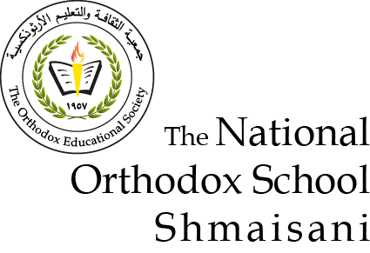

Starters

* Use the particle model to describe solid, liquids and gases and to explain the properties of solids and liquids.
* Draw particle diagrams of solids and gases to model the arrangement of particles in the different states of matter.

Main course

**CHOOSE ONE DISH**

* Describe the processes of freezing and melting using the particle model and relate the processes to changes in temperature. (write between 50-70 words)
* Make a table and write the difference between boiling and evaporation.

Dessert

**CHOOSE ONE DISH**

* Draw the process of water cycle.
* Draw a diagram that shows the changes in states and write the names of the processes on the arrows. (be creative)

Evaporation boiling

It changes from liquid to gas without boiling. Change state from liquid to gas

No bubbles are formed. Bubbles are formed

slow fast

takes place only from the exposed surface of the liquid. Occurs throughout the

liquid

occurs at all temperature occurs at a definite

temperatures boiling point

evaporation –condensation-precipitation