**The National Orthodox School /Shmaisani**

**Subject: Chemistry**

**Name: Talin Yassin Topic: States of matter**

**Date:23/9/2022 Grade-Section: 6CS- all sections**



Starters

* Use the particle model to describe solid, liquids and gases and to explain the properties of solids and liquids.
* Draw particle diagrams of solids and gases to model the arrangement of particles in the different states of matter.

Main course

**CHOOSE ONE DISH**

* Describe the processes of freezing and melting using the particle model and relate the processes to changes in temperature. (write between 50-70 words)
* Make a table and write the difference between boiling and evaporation.

Dessert

**CHOOSE ONE DISH**

* Draw the process of water cycle.
* Draw a diagram that shows the changes in states and write the names of the processes on the arrows. (be creative)

Starters

* 1.a The solid’s particles are close to each other and they can’t move.
* 1.b The liquid’s particles only vibrate close to each other without a pattern.
* 1.c The gas’s particles are far apart and floating everywhere.

2)

Solid’s particles liquid’s particles gas’s particles

|  |
| --- |
| Main course |
|  |
|  |
|  |
|  |
|  |
|  |
|  |
|  |
|  |
|  |

|  |  |
| --- | --- |
| Boiling | Evaporation |
| Boiling is the change of state from liquid to gas, as it only happens if the liquid is hot enough and starts to bubble.  The boiling point of water is mainly  100 degrees Celsius,  when you heat liquid water, bubbles of steam form everywhere in the liquid, the particles are spread out.  This is Boiling! | Evaporation is the change of state from liquid to gas that can happen at any temperature.  They move around, sliding over each other.  Some particles move faster-moving particles leave the surface of liquid. They separate from each other, forming gas.  This is evaporation! |

Dessert

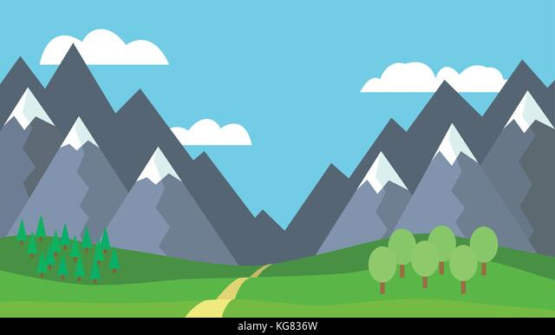

precipitation

collection

evaporation

condensation