**The National Orthodox School /Shmaisani**

**Subject: Chemistry**

**Name: lareine hammas Topic: States of matter**

**Date: 20/9/2022 Grade-Section: 6CS- all sections**



Starters

* Use the particle model to describe solid, liquids and gases and to explain the properties of solids and liquids.
* Draw particle diagrams of solids and gases to model the arrangement of particles in the different states of matter.

Main course

**CHOOSE ONE DISH**

* Describe the processes of freezing and melting using the particle model and relate the processes to changes in temperature. (write between 50-70 words)
* Make a table and write the difference between boiling and evaporation.

Dessert

**CHOOSE ONE DISH**

* Draw the process of water cycle.
* Draw a diagram that shows the changes in states and write the names of the processes on the arrows. (be creative)

Question 1: particles in the solid state are tightly packed together, while in the liquid state particles are close together and are not in a specific pattern, in the gas state particles are far away from each other

Question 2:

|  |  |
| --- | --- |
| Boiling | Evaporation |
| Boiling can only happen at the boiling point | Evaporation can happen at any temperature |
| Boiling occurs throughout the whole body of the liquid | Evaporation happens only at the surface of the liquid |
| Bubbles are formed | No bubbles are formed |
| A process in which the liquid state changes from liquid to gas | A process in which the liquid state changes from liquid to gas without boiling |

Question 3: 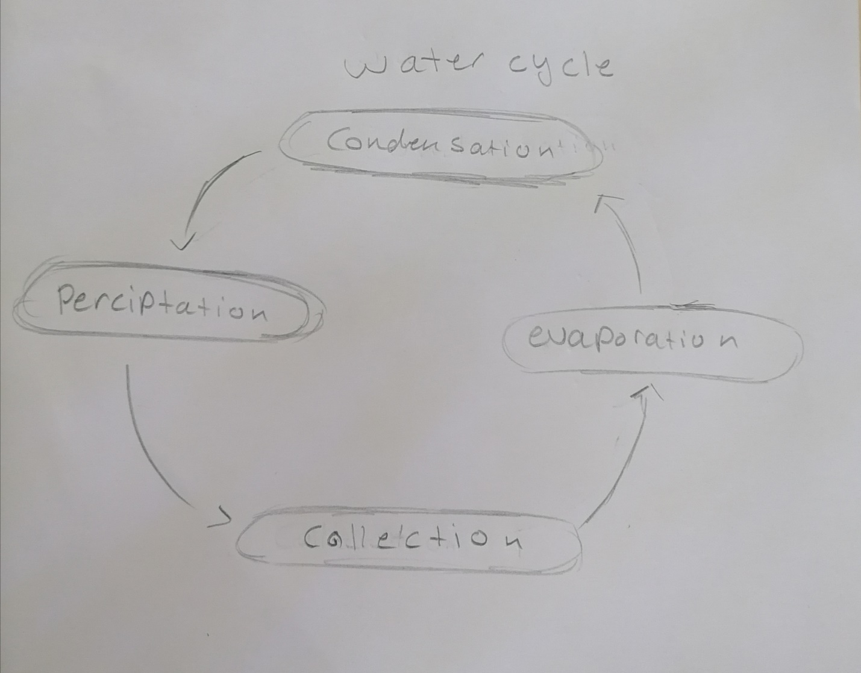

Question 4: 