**Name: Catherine Habash Homework: Food webs**

**Date: Friday,23rd September 2022 Grade-Section: 6 CS – All Sections**

**Objective: Identify the parts of a food chain and food web.**

**Question One:**

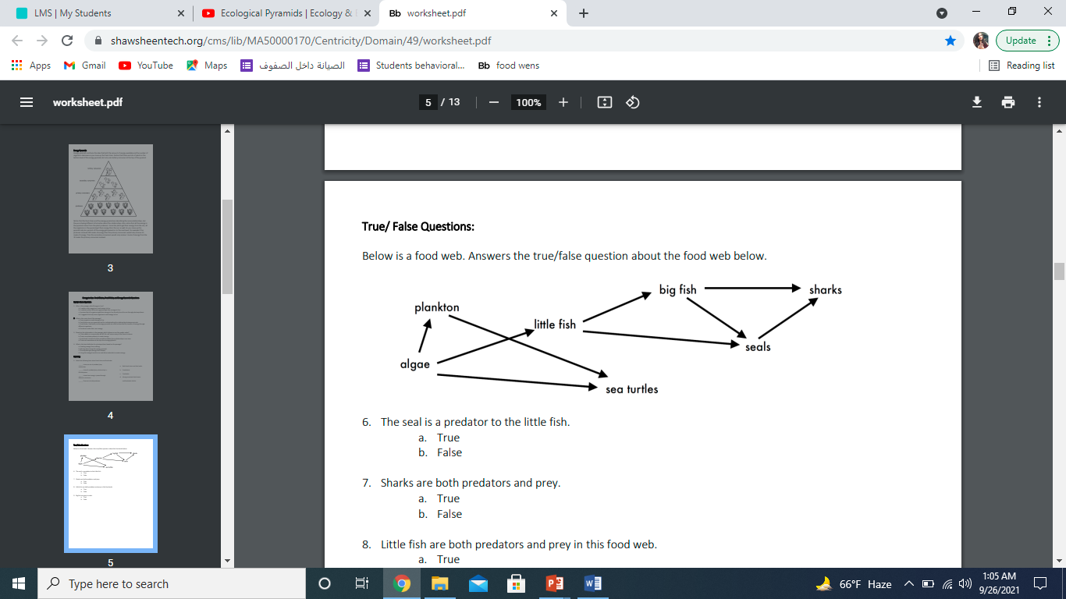Answer the following questions about the food web below.

1. The big fish is a predator to the _little fish_______________________.
2. Which animals would have a bigger food supply if the number of little fish decreased? Sea turtle, plankton__________________________.
3. Which organism would have the least biomass in this food web? _algae ______________.
4. Sharks are both predators and prey.

a. True

b. False

1. Decomposers are very important for life on Earth.

Explain what the role of decomposers in food webs is.

Decomposers feed on dead animals and plants so they can return nutrients back to the soil and they avoid buildup of dead animals and plants

________________________________________________________________________