**Name: nicola Homework: Food webs**

**Date:23/9/2022 Grade-Section: 6 CS – All Sections**

**Objective: Identify the parts of a food chain and food web.**

**Question One:**

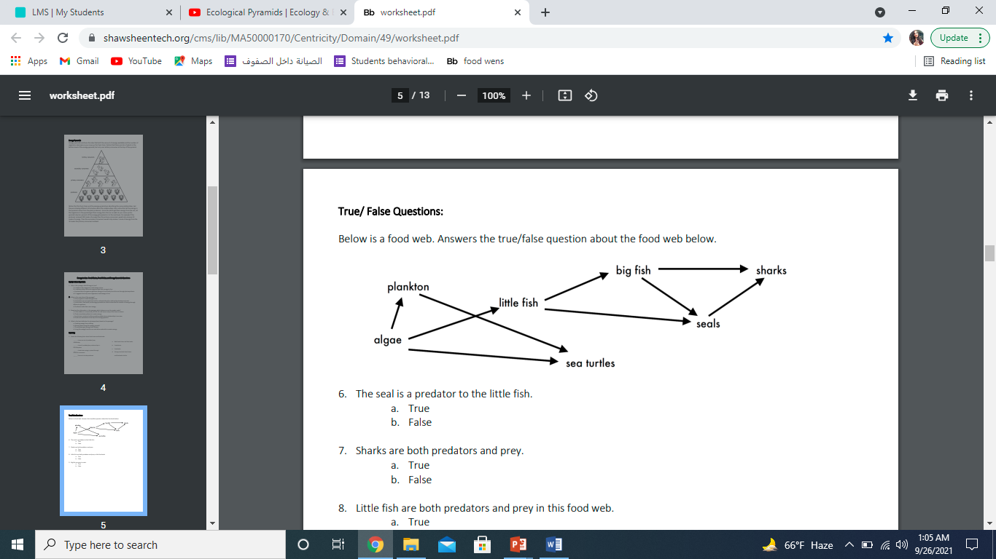Answer the following questions about the food web below.

1. The big fish is a predator to the: little fish.
2. Which animals would have a bigger food supply if the number of little fish decreased? Sharks,because the little fish is the prey to the big fish and the big fish will starve so sharks will eat more.
3. Which organism would have the least biomass in this food web? sharks.
4. Sharks are both predators and prey.

a. True

b. False

1. Decomposers are very important for life on Earth.

Explain what is the role of decomposers in food webs.

The decomposers will break down the dead bodies of these animals into nutrients for plants