**Name: Jad alfar Homework: Food webs**

**Date: 23/9/2022 Grade-Section: 6 CS – All Sections: C**

**Objective: Identify the parts of a food chain and food web.**

**Question One:**

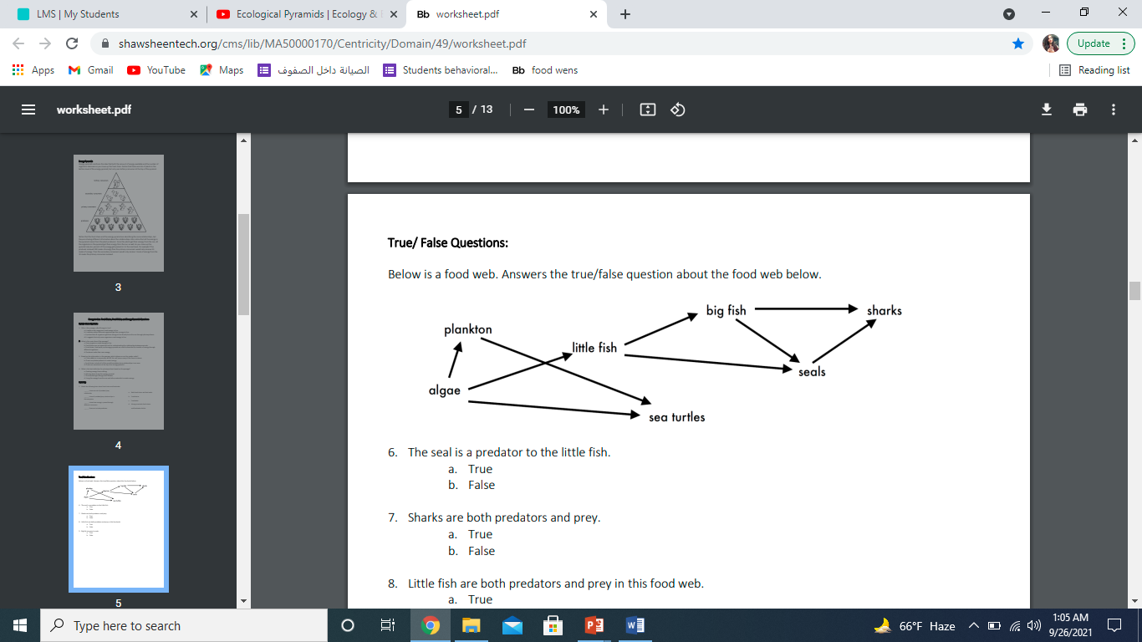Answer the following questions about the food web below.

1. The big fish is a predator to the ***little fish***
2. Which animals would have a bigger food supply if the number of little fish decreased? ***Sea turtles/plankton***
3. Which organism would have the least biomass in this food web? ***The sharks***
4. Sharks are both predators and prey.

a. True

***b. False***

1. Decomposers are very important for life on Earth.

Explain what is the role of decomposers in food webs: ***decomposers are organisms the break down dead animals and plants and send mineral salts back to the soil.***