Hussam Abu Ghattas

STARTERS

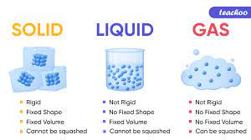

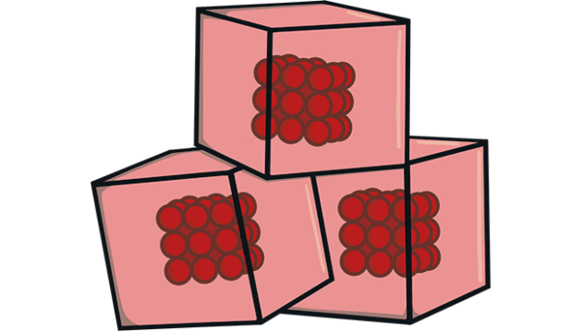

* Solid
* Particles are packed
* Very little spaces
* Low energy only vibrate
* Particles are strongly helped together

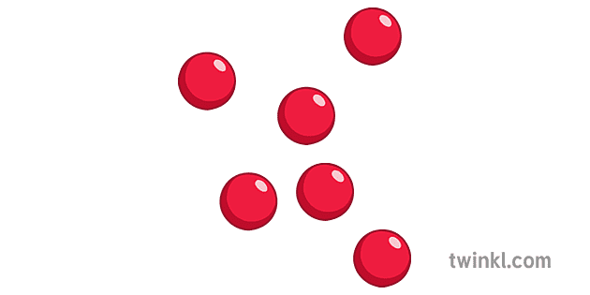

* Gases
* Particles are very fare apart
* Held together by very weak force
* They move randomly in all directions

MAIN COURSE

Difference between evaporation and boiling

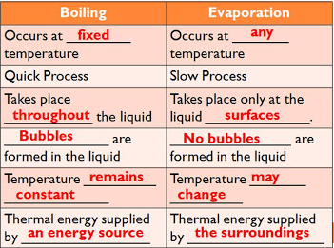

DESSERT

Diagram showing changes in states of matter.

