**Name: rita Homework: Food webs**

**Date: Grade-Section: 6 CS – All Sections**

**Objective: Identify the parts of a food chain and food web.**

**Question One:**

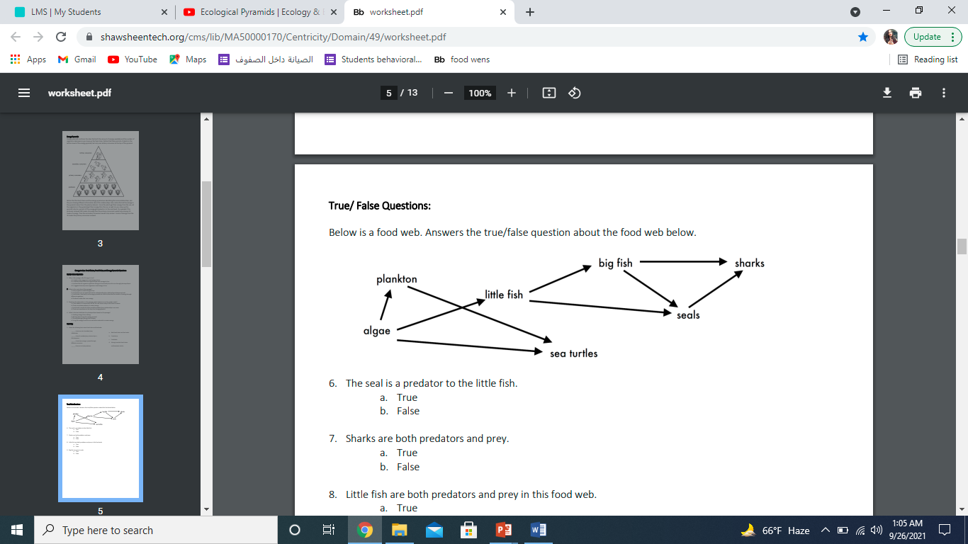Answer the following questions about the food web below.

1. The big fish is a predator to the _____little fish___________.
2. Which animals would have a bigger food supply if the number of little fish decreased? _____sea turtles

1. Which organism would have the least biomass in this food web shark________.
2. Sharks are both predators and prey.

a. True

b. False

1. Decomposers are very important for life on Earth.

Explain what is the role of decomposers in food webs.

__decomposers eat dead plants and dead animals. They break down the waste and remains into simple chemicals and nutrients. These chemicals can be used again by other living things