**The National Orthodox School /Shmaisani**

**Subject: Chemistry**

**Name: Tia haddad Topic: States of matter**

**Date: Grade-Section: 6CS- all sections**

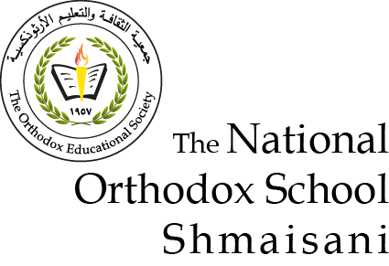

Starters

* Use the particle model to describe solid, liquids and gases and to explain the properties of solids and liquids.
* Draw particle diagrams of solids and gases to model the arrangement of particles in the different states of matter.

Main course

**CHOOSE ONE DISH**

* Describe the processes of freezing and melting using the particle model and relate the processes to changes in temperature. (write between 50-70 words)
* Make a table and write the difference between boiling and evaporation.

Dessert

**CHOOSE ONE DISH**

* Draw the process of water cycle.
* Draw a diagram that shows the changes in states and write the names of the processes on the arrows. (be creative)

Questions 1: Use the particle model to describe solid, liquids and gases and to explain the properties of solids and liquids

Solid:

Arrangement: the particles are arranged in a pattern.

Movement: The particles vibrate in place

Grip: The particles of a solid hold each other very strongly

Liquid :

Arrangement: The particles are arranged randomly

Movement: The particles vibrate in place

Grip: The particles of a liquid hold each other strongly

Gases:

Arrangement: The particles are arranged randomly

Movement: The particles move randomly

Question 2: Draw particle diagrams of solids and gases to model the arrangement of particles in the different states of matter.

solid

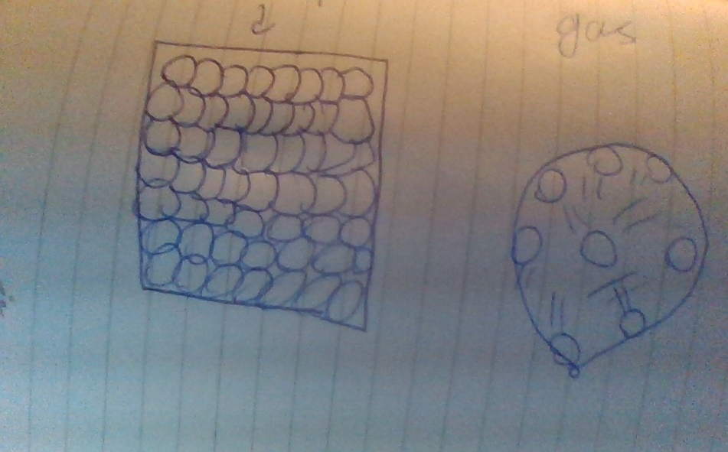

Main course

* Question : Make a table and write the difference between boiling and evaporation.

|  |  |  |
| --- | --- | --- |
| differences | evaporation | boiling |
| The temperature | Any temperature that’s over 0 **°C** | Has a certain boiling point when it starts to boil depending on the material |
| |  | | --- | | time | | Bubbles forming | | |  | | --- | | slow | | no | | |  | | --- | | fast | | yes | |
|  |  |  |

Dessert

Question :

