**The National Orthodox School /Shmaisani**

**Subject: Chemistry**

**Name: Topic: States of matter**

**Date: Grade-Section: 6CS- all sections**

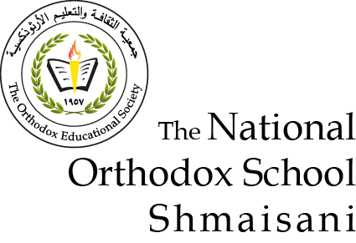

Starters

* Use the particle model to describe solid, liquids and gases and to explain the properties of solids and liquids.
* Draw particle diagrams of solids and gases to model the arrangement of particles in the different states of matter.

Main course

**CHOOSE ONE DISH**

* Describe the processes of freezing and melting using the particle model and relate the processes to changes in temperature. (write between 50-70 words)
* Make a table and write the difference between boiling and evaporation.

Dessert

**CHOOSE ONE DISH**

* Draw the process of water cycle.
* Draw a diagram that shows the changes in states and write the names of the processes on the arrows. (be creative)

***1. gas are well separated with no regular arrangement. liquid are close together with no regular arrangement. solid are tightly packed, usually in a regular pattern.***

***2. in a solid, the atoms and molecules are closely bonded that they vibrate in place but don't move around.  In a liquid, the atoms and molecules are loosely bonded.***

***Boiling***

***Gas***

***Solid***

***does not result in cooling***

***leads to cooling***

***produces lots of bubbles***

***can occur throughout the liquid***

***occurs only from the surface of the liquid***

***does not produce bubbles***

***Slower***

***Faster***

***Evaporation***

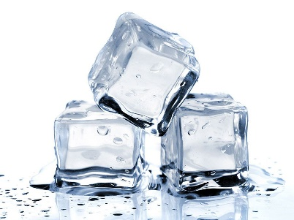 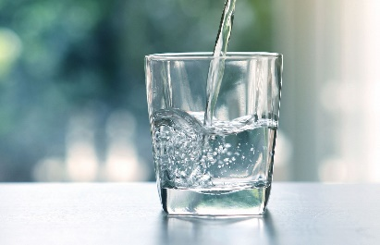 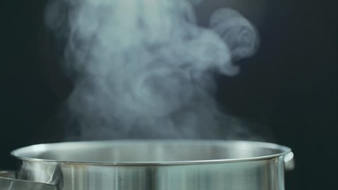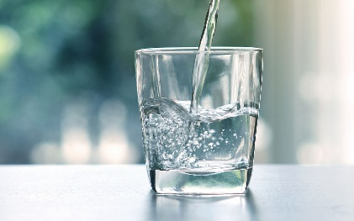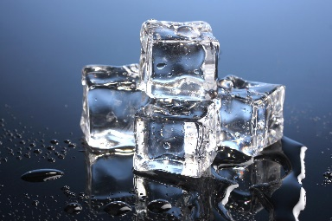

***Freezing***

**Condensation**

***Evaporation***

***Melting***