**The National Orthodox School /Shmaisani**

**Subject: Chemistry**

**Name: Topic: States of matter**

**Date: Grade-Section: 6CS- all sections**

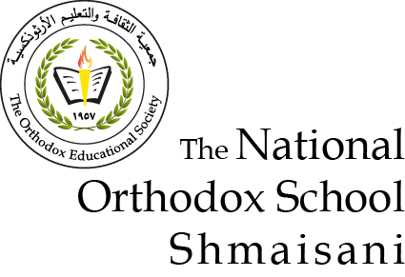

Starters

* Use the particle model to describe solid, liquids and gases and to explain
* The properties of solids and liquids.

Solids: It cannot flow, it can be compressed only a tiny bit only changes shape if you apply force to it.

Liquids: It can flow, it can be compressed a tiny bit and takes shape of the bottom of the container.

Gases: It can flow it can be compressed a lot and takes shape of the whole container.

* Draw particle diagrams of solids and gases to model the arrangement of particles in the different states of matter.

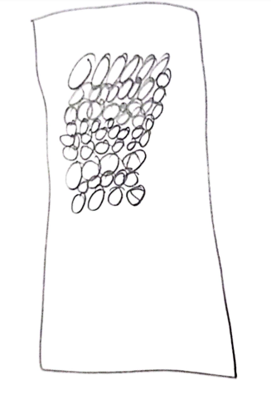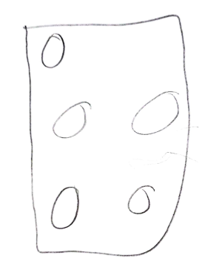

Gas

Solid

Main course

**CHOOSE ONE DISH**

* Describe the processes of freezing and melting using the particle model and relate the processes to changes in temperature. (write between 50-70 words)
* Make a table and write the difference between boiling and evaporation.

|  |  |  |  |
| --- | --- | --- | --- |
| Process | Change of state | temperature | How particles leave the liquid |
| Evaporating | Liquid to gas | At any temperature | From the surface |
| Boiling | Liquid to gas | At boiling point | Bubbles of the substance in the gas state form everywhere in the liquid then the bubbles rise to the surface and escape. |

Dessert

**CHOOSE ONE DISH**

* Draw the process of water cycle.
* Draw a diagram that shows the changes in states and write the names of the processes on the arrows. (be creative)

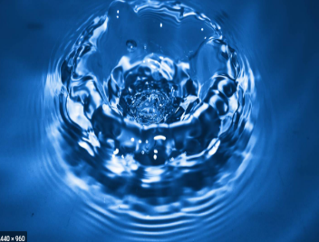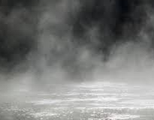 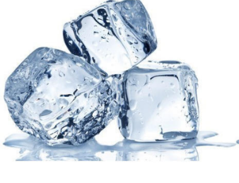

Evaporation

Condensing

Freezing

Melting