**Name: Homework: Food webs**

**Date: Grade-Section: 6 CS – All Sections**

**Objective: Identify the parts of a food chain and food web.**

**Question One:**

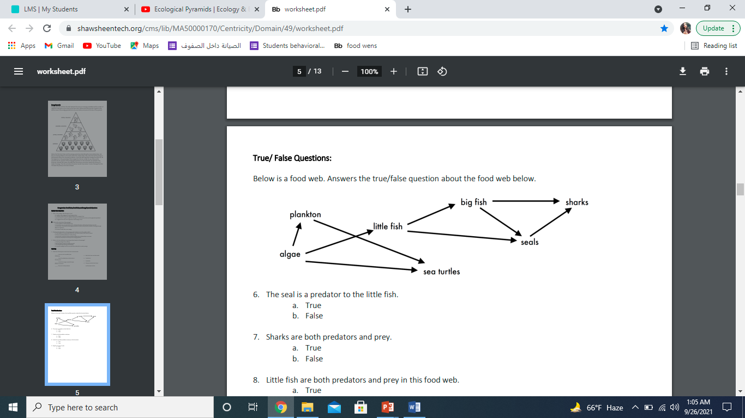Answer the following questions about the food web below.

1. The big fish is a predator to the little fish.
2. Which animals would have a bigger food supply if the number of little fish decreased? Plankton.
3. Which organism would have the least biomass in this food web? shark .
4. Sharks are both predators and prey.

a. True

b. False ✅

1. Decomposers are very important for life on Earth. ✅
2. Explain what is the role of decomposers in food webs.
3. It breaks down dead animals and returns the mineral-salts back to the soil so the producer can grow again