**Henry Ford**

Henry ford, born on July 30th 1863, was an American industrialist, business magnate, founder of the Ford Motor Company, and chief developer of the assembly line technique of mass production. Young Henry Ford showed an early interest in mechanics. By the time he was 12, he was spending most of his spare time in a small machine shop he had equipped himself. Ford could have followed in his father’s footsteps and become a farmer. But Henry was fascinated by machines and was willing to take risks to pursue that fascination.

Instead of farming he operated and serviced portable steam engines used by farmers, occasionally worked in factories in Detroit, and cut and sold timber from 40 acres of his father’s land. By now Ford was demonstrating another characteristic a preference for working on his own rather than for somebody else. Henry was trying to build horseless carriages, aided by a team of friends, his experiments culminated in 1896 with the completion of his first self-propelled vehicle, [the Quadricycle](https://www.thehenryford.org/collections-and-research/digital-collections/artifact/252049/). It had four wire wheels that looked like heavy bicycle wheels, was steered with a tiller like a boat, and had only two forward speeds with no reverse.

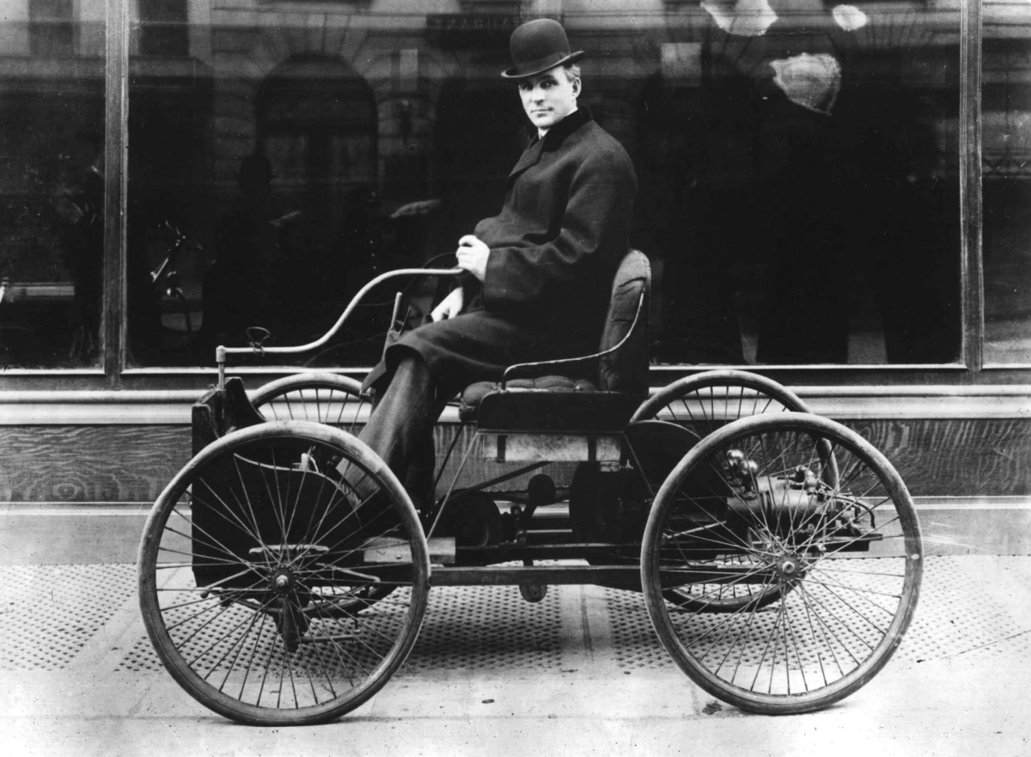

A [second car](https://www.thehenryford.org/collections-and-research/digital-collections/artifact/11391) followed in 1898. Ford now demonstrated one of the keys to his future success the ability to articulate a vision and convince other people to sign on and help him achieve that vision.  The[new company](https://www.thehenryford.org/collections-and-research/digital-collections/artifact/369197/) failed, as did a second. To revive his fortunes Ford took bigger risks, [building and even driving racing cars](https://www.thehenryford.org/artifact/199258/). The success of these cars attracted additional financial backers, and on June 16, 1903 Henry incorporated his third automotive venture,[Ford Motor Company](https://www.thehenryford.org/collections-and-research/digital-resources/popular-topics/ford-company-chronology/).

In order to meet overwhelming demand for the revolutionary vehicle, Ford introduced revolutionary new mass-production methods, including large production plants, the use of standardized, interchangeable parts and, in 1913, the world's first moving assembly line for cars. Henry Ford took inspiration from the past, saw opportunities for the future, and believed in technology as a force for improving people's lives. To him, technology wasn't just a source of profits, it was a way to harness new ideas and, ultimately, further democratize American life.

