**The National Orthodox School /Shmaisani**

**Subject: Chemistry**

**Name: Karam Gammoh Topic: States of matter**

**Date: 23-4-2022 Grade-Section: 6CS- all sections**



Starters

* Use the particle model to describe solid, liquids and gases and to explain the properties of solids and liquids.

**Solid**:

It has a fixed mass

It has a fixed volume

It has a fixed shape

**Liquid:**

It has a fixed mass

It has a fixed volume

Its shape changes

**Gas**

It has a fixed mass

It has a fixed volume

Its shape changes

* Draw particle diagrams of solids and gases to model the arrangement of particles in the different states of matter.

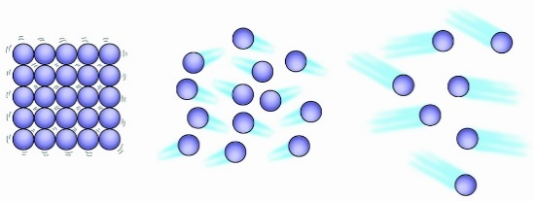**Solid:**

Its particles has regular arrangement

Its participles move by vibrating

Its particles are very close to each other

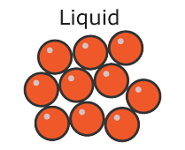**Liquid:**

Its particles has random arrangement

Its participles move around each other

Its particles are close to each other

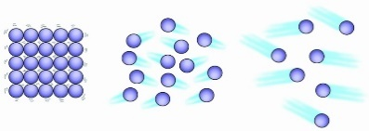**Gas:**

Its particles has random arrangement

Its participles move quickly in all directions

Its particles are far apart

Main course

**CHOOSE ONE DISH**

* Describe the processes of freezing and melting using the particle model and relate the processes to changes in temperature. (write between 50-70 words)

Freezing occurs when a liquid is cooled and turns to a solid. Eventually the particles in a liquid stop moving about and settle into a stable arrangement, forming a solid. This is called freezing and occurs at the same temperature as melting.

Melting occurs when a solid is heated and turns to liquid. The particles in a solid gain enough energy and start to move around each other but staying close to.

When the solid starts to melt until it has completely turned into a liquid its temperature doesn’t rise. All the heat energy is used to separate the particles so they can flow over one another.

Dessert

**CHOOSE ONE DISH**

* Draw the process of water cycle.

