**Name: nour karsou Homework: Food webs**

**Date: 22/9/2022 Grade-Section: 6 CS – All Sections**

**Objective: Identify the parts of a food chain and food web.**

**Question One:**

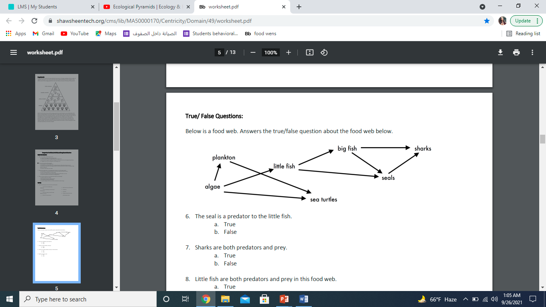Answer the following questions about the food web below.

1. The big fish is a predator to the _______seals_________________.
2. Which animals would have a bigger food supply if the number of little fish decreased? _______algae___________________.
3. Which organism would have the least biomass in this food web? ___plankton____________.
4. Sharks are both predators and prey.

a. True

b. False

1. Decomposers are very important for life on Earth.

Explain role of what is the decomposers in food webs.

_ Decomposers, like **fungi and bacteria**, complete the food chain. Decomposers turn organic wastes, such as decaying plants, into inorganic materials, such as nutrient-rich soil. _______________________________________________________________________