**The National Orthodox School /Shmaisani**

**Subject: Chemistry**

**Name: Topic: States of matter**

**Date: Grade-Section: 6CS- all sections**

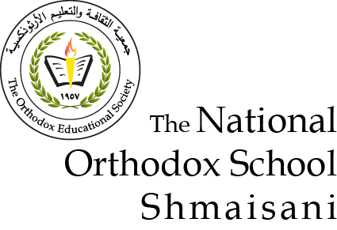

Starters

* Use the particle model to describe solid, liquids and gases and to explain the properties of solids and liquids.
* Draw particle diagrams of solids and gases to model the arrangement of particles in the different states of matter.
* **Greek Salad:** **A traditional Greek salad consists of solids know as: sliced cucumbers, tomatoes, green bell pepper, red onion, olives, and feta cheese.**
* **All of these are fixed solides. You may wonder what does fixed mean it means that is shape doesn’t change unless u add a great force on it.**
* **As well as It’s volume and mass doesn’t change at all.**
* **It also consists of liquids such as:solive oil and lemon juice the liquids volume is fixed as well as the mass but the shape isn’t fixed because liquids take the shape of any container.**
* **And finally we have a drink know as pepsi`: pepsi is a fizzy drink that containes gases in it. They’re mass is fixed but ther volume and shape isn’t fixed**

Main course

**CHOOSE ONE DISH**

* Describe the processes of freezing and melting using the particle model and relate the processes to changes in temperature. (write between 50-70 words)
* Make a table and write the difference between boiling and evaporation.

Dessert

**CHOOSE ONE DISH**

* Draw the process of water cycle.
* Draw a diagram that shows the changes in states and write the names of the processes on the arrows. (be creative)