**The National Orthodox School /Shmaisani**

**Subject: Chemistry**

**Name: Topic: States of matter**

**Date: Grade-Section: 6CS- all sections**



Starters

* Use the particle model to describe solid, liquids and gases and to explain the properties of solids and liquids.

-Draw particle diagrams of solids and gases to model the arrangement of particles in the different states of matter.

Main course

**CHOOSE ONE DISH**

* Describe the processes of freezing and melting using the particle model and relate the processes to changes in temperature. (write between 50-70 words)
* Make a table and write the difference between boiling and evaporation.

Dessert

**CHOOSE ONE DISH**

* Draw the process of water cycle.
* Draw a diagram that shows the changes in states and write the names of the processes on the arrows. (be creative)

Starters

Solid is the matter that has definite size and shape, they could be hard or soft.

Liquid takes the shape of any container, they could be thick or thin.

Gas is a matter that has no definite shape and takes the shape of its container.

|  |  |  |
| --- | --- | --- |
|  | **solid** | **liquid** |
| **Its particles are like** | Definite size and shape | No definite shape  It takes the shape any container |
| **arrangement** | Regular | Random |
| **movement** | Vibrate about a fixed position | Move around each other |
| **How far** | Very close | Close but not as close as solid |
| **Strength of particles** | Very strong | Weaker than solid |

**Solid Gas**

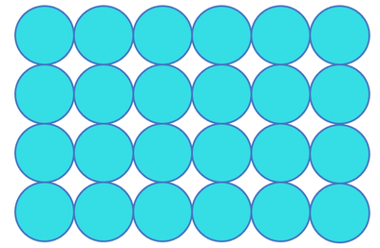 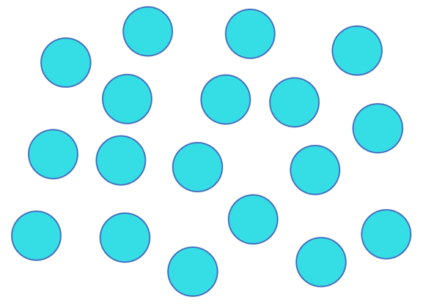

Main course

difference between boiling and evaporation

|  |  |
| --- | --- |
| Boiling | Evaporation |
| Change from liquid to gas state | Change from liquid to gas state without boiling |
| Fast process | Slow process |
| Bubbles are formed | No bubbles are formed |
| Occurs throughout the liquid | Takes place only from the surface of the liquid |
| Occurs at a definite temperature-boiling point | Occurs at all temperatures |

Dessert

the changes in states

melting boiling

Energy increases Energy increases

gas

liquid

solid

Energy decreases Energy decreases

freezing condensation