Adolf Dassler (Adidas Founder)

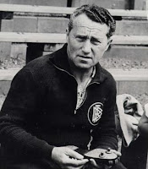

1900 - 1978

Adolf Dassler is an inventor and entrepreneur who founded the German sportwear company Adidas.

**His Life & Nationality**

Adolf (Adi) Dassler is a German inventor who was born in 1900 & dies in 1978.

**How did he start his business?**

Adi started his business by repairing the shoes in his town, post the war in Germany he started to use materials from the soldiers’ helmets, parachutes, bread pouches supplied leather, belts since there was no reliable supply post the war.

Adi started to modify those available materials to help him in the production.

**His Passion**

Developing shoes was his hobby, and not his job and since he had this passion. Adi’s story is considered of one of the successful entrepreneurs’ actual stories in our life.

He was able to establish one of the largest companies worldwide in the sports brands.

As a result of his concepts, Adi Dassler built the largest manufacturer of sportswear and equipment. At the time of his death, Adidas had 17 factories and annual sales of one billion Marks.