**The National Orthodox School /Shmaisani**

**Subject: Chemistry**

**Name: Topic: States of matter**

**Date: Grade-Section: 6CS- all sections**

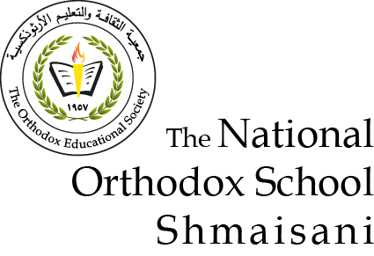

Starters

* Use the particle model to describe solid, liquids and gases and to explain the properties of solids and liquids.
* Draw particle diagrams of solids and gases to model the arrangement of particles in the different states of matter.

Main course

**CHOOSE ONE DISH**

* Describe the processes of freezing and melting using the particle model and
* relate the processes to changes in temperature. (write between 50-70 words)
* Make a table and write the difference between boiling and evaporation.

Dessert

**CHOOSE ONE DISH**

* Draw the process of water cycle.
* Draw a diagram that shows the changes in states and write the names of the processes on the arrows. (be creative)

1 Solid; in solid the particles touch each other and they are in a fixed position and vibrate on spot

2 Liquid; in liquid the particles touch each other, the particles are not in a pattern, move around randomly

3 Gas; in gas the particles are far apart, are not in a pattern and move very fast

Solid gas

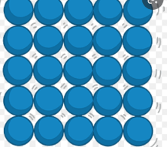

|  |  |  |  |
| --- | --- | --- | --- |
| process | Change of state | temperature | How particles leave the liquid |
| evaporating | From liquid to gas | Happens at any temperature | Particles leave the liquid surface |
| boiling | From liquid to gas | Happens at the boiling point | Bubbles of the substance in gas state from everywhere in liquid the bubbles rise to the surface and escape |

**Liquid water evaporates into water vapor, condenses to form clouds, and precipitates back to earth in the form of rain**